Sample Data Exchange Agreement
[Amended to reflect the new Minor Offense Rules effective April 15, 2013]

Data Exchange Agreement

between

-------------------------------------

and

The Alaska Court System

FOR

Electronic Filing of Minor Offense Citations at --------- Court

TABLE OF CONTENTS
1. Parties 1
2. Effective Date 1
3. Purpose 1
4. Scope and Effect 1
5. Agency or Municipal Filing Authority 2
6. Security and Data Integrity 3
6.1. Officer Identification 3
6.2. Electronic Signature, Authentication and Nonrepudiation 4
6.3. Data Integrity 5
6.4. Citation Image Retrieval 7
6.5. Data Transfer Protocol 7
6.6. Data Transfer Schedule 7
6.7. Encryption 8
6.8. Processing Outcomes 8
6.9. Court Change Log 8
7. Contact Information 8
8. Required Notice and Correction of Noncompliance 9
9. Restrictions on Access/Dissemination 9
10. Record Retention 9
11. Governing Laws and Rules 9
12. Agreement Duration & Changes 10
13. Signatures 11
Attachment 1: Documentation substantiating the process by which the Agency ensures that the Unique Person Identifier cannot be duplicated for another officer employed by or acting on behalf of the Agency and substantiating that the Agency Chief will be responsible for the signatures of those officers
Attachment 2: Agency’s documentation of the process from the creation of the citation through its delivery to the ACS
Attachment 3: Acknowledgement, Certification and Signature Form
Attachment 4: Documentation of how the Agency will provide the Alaska Court System with the ability to view an electronic version of the paper citation that the charging officer issued to the defendant
Attachment 5: Memorandum of Agreement between DPS and the ACS for the Electronic Transmittal of Law Enforcement Agency Minor Offense Citations to the Alaska Court System

Parties
This Electronic Filing of Minor Offense Citation Agreement is made between:

The _____________________Police Department (“the Agency”)

AND

The Alaska Court System (“the ACS”)

Effective Date
This agreement becomes effective once signed by both parties.

Purpose
  - The purpose of this agreement is to ensure that, compared to manually filed paper citations, minor offense citations filed electronically result in the same or better

    - compliance with laws and court rules;

    - court disposition timeliness; and

    - use of resources for both parties.

  - This agreement is made in accordance with Alaska Rules of Minor Offense Procedure (“Minor Offense Rules”) Rule 22(a), which allows the Alaska Court System and law enforcement agencies to agree to procedures for filing minor offense citations electronically, if the Agency’s systems and procedures provide certain assurances, as listed in Minor Offense Rule 22(a)(1)-(6). In this agreement, the Agency provides assurance that each of the rule requirements have been met thereby allowing the ACS to enter this agreement.

Scope and Effect
Because this agreement ensures that the requirements of Minor Offense Rule 22(a) are met, and because a charging officer’s electronic or digital signature on a citation for a minor offense is the legally binding equivalent of the officer’s handwritten signature (Minor Offense Rule 22(b)), the court will accept for filing any Agency citation issued by an electronic device and signed electronically by an officer employed by, or expressly authorized by the Agency to issue citations on behalf of the Agency, whether the citation is filed electronically or manually by the Agency or provided to the court by the defendant.

The Agency agrees to file minor offense citations electronically however a citation may be manually filed by the Agency whenever the Agency reports equipment issues. The Agency agrees to resolve such issues in a timely manner in order to resume electronic filing.

Agency or Municipal Filing Authority
The Agency agrees to use the agency code assigned to the Agency in the ACS’ case management system code table for electronic filing. The required agency codes are listed at:
http://www.courtrecords.alaska.gov/majic/CourtCodes/CourtAgencyCodes.xls

The Agency agrees, as required by Minor Offense Rule 3(b), that each citation issued by the Agency will include the statute, regulation or ordinance that the defendant is alleged to have violated as identified in the uniform table of minor offenses maintained by the ACS.

To ensure that the minor offense table is current the Agency agrees to provide the ACS with timely notice of any changes to its ordinances and fine schedule pursuant to the instructions provided on the ACS website at: http://www.courts.alaska.gov/umot.htm. The ACS agrees to update the ACS electronic table of offenses as soon as practicable after receiving notice of any change.

The Agency agrees that the electronic process will not be used to issue warning citations.

The Agency agrees that the electronic process will not be used to issue parking citations.

The Agency or Municipality files the following citations with the court (check all that apply):

  - citations required to be filed with the court under AS 12.25.210(a);

  - citations required to be filed with the municipal clerk under AS 12.25.210(a), and Administrative Rule 49, and paragraph 1 of Administrative Bulletin 39, for which

    - the Agency is seeking a default judgment and, in accordance with Minor Offense Rule 9, certifies by signature of this agreement that (1) at least 15 (fifteen) days have elapsed since the Agency mailed a default warning letter to the defendant; (2) no more than 6 (six) months have elapsed since the date the citation was issued to the defendant; and (3) the defendant has not submitted partial or full payment to the municipality for amounts due for the citation.

The Agency will not electronically file a citation for which any amount due has been accepted by the municipality.

If a defendant fails to respond to a citation filed with the municipality and the municipality seeks a default judgment, the municipality must submit an affidavit from a municipal employee stating that the municipality sent the defendant the warning letter required in this section and that the defendant failed to respond. The municipality must provide the ACS with the municipality’s procedures for verifying that the defendant was sent the warning notice and failed to respond. Minor Offense Rule 9(a)(3).

A citation with a request for default judgment and the affidavit must be filed with the court within six months of the issuance of the citation. Minor Offense Rule 9(a)(3).

Or:

5.2.2. the defendant has pleaded not guilty and requested a court hearing;

5.3. citations filed with the court under AS 12.25.210(a), Administrative Rule 49 and paragraph 2 of Administrative Bulletin 39, under which the municipality exercised the option to file its citations with the court.

Security and Data Integrity

Officer Identification
The ACS will maintain an electronic table of officers authorized to file citations with the court on behalf of the Agency. The ACS will not accept an electronically filed citation issued by an officer who is not listed in the table maintained by the ACS. The Agency shall immediately notify the ACS as provided in section 7 of this agreement when an officer is hired or terminated or changes his or her name, or when an officer is granted or relieved of authority by the agency to issue citations on the Agency’s behalf. The notice must include the officer’s name, Unique Person Identifier (UPI) used by the Agency, and effective date of hire, termination or other change. If an officer ceases to be employed by the Agency or no longer has authority to issue citations on behalf of the Agency, and a citation issued by that officer is submitted to the ACS after termination of employment or other revocation of the officer’s authority to issue citations on the Agency’s behalf, the citation will be rejected.

The Agency uses:

Perm ID

Other Unique Person Identifier (UPI)

Attachment 1 is documentation substantiating the process by which the Agency ensures that the UPI cannot be duplicated for another officer employed by that Agency or for an officer expressly authorized to issue citations on behalf of that Agency.

Electronic Signature, Authentication and Nonrepudiation
In place of a handwritten signature on the citation, the ACS will accept an electronic signature consisting of the printed name and Unique Person Identifier of the officer who issued the citation during the time the officer was employed by the Agency or was expressly authorized to issue citations on the Agency’s behalf.

To ensure authentication and nonrepudiation of an officer’s electronic signature, the Agency certifies that the following statements are true:

    - An officer’s printed name and UPI can appear on a citation issued by the Agency’s automated citation application only if the officer’s identity has been authenticated. The officer’s identity is authenticated by

Entering the officer’s user name and password to log into the Agency’s citation issuing application.

Other (Attach documentation)

    - The officer’s name and UPI are automatically printed on the citation according to the authentication procedures described in this section. An officer cannot overwrite or change the name or UPI on a citation that is issued electronically.

    - Each officer authorized to issue an electronic citation on behalf of the Agency has been instructed by the Agency in writing and has signed a written acknowledgement of password security policies and procedures. The Agency’s acknowledgement form requires the officer to certify that the officer understands that affixing an electronic signature to a citation is the legally binding equivalent of signing a citation by hand and that the officer intends to be bound by that electronic signature. Attachment 3 is the Agency’s acknowledgement, certification and signature form. The Agency maintains a copy of each acknowledgement form and agrees to make it available to the ACS upon request.

    - An officer cannot deny responsibility for an electronically issued citation displaying the officer’s name and UPI used by the Agency because the officer’s name and UPI will be printed on the citation. The use of one officer’s password by a different officer to create the citation is a violation of the Agency’s policies and this agreement.

    - The Agency employs policies that hold individual officers accountable and is responsible for actions initiated under their electronic signatures. The Agency understands and agrees that the Agency is legally responsible for the signature of any officer employed by the Agency and for the signature of any officer expressly authorized by the Agency to issue citations on the Agency’s behalf, such as a task force officer.

Data Integrity
6.3.1. ACS
The ACS has published a list of the data elements, Extensible Markup Language (XML) schema, and sample schema instance for the electronic citation record to be filed with the court on the Multi-Agency Justice Integration Consortium (MAJIC) website.
See http://www.courtrecords.alaska.gov/majic/ECF31/CitationDomain GJXDMMapping.xls and for a sample schema go to:
http://www.courtrecords.alaska.gov/majic/ECF31/AKMOCitation.v31.xsd
This documentation indicates which data elements are mandatory and optional. If the Agency submits a citation to the Department of Public Safety (DPS) repository for forward transmission to the ACS with a data element missing or uses the incorrect code or format, the following will occur:

- For a mandatory data element, the ACS will reject the electronic filing and provide DPS with an error message for the reason(s) the citation is rejected. DPS will forward the error message to the Agency within one working day pursuant to Attachment 5 to this Agreement. Attachment 5 is the DPS-ACS Agreement for the Electronic Transmittal of Law Enforcement Agency Minor Offense Citations to the Alaska Court System;

- For an optional data element, the ACS will accept the filing and create the citation record in the ACS database without the element in question.

6.3.2. The Agency
The Agency has provided assurances that the integrity of data on the citation from the time it is issued to the time it is electronically filed with the court will be protected. Attachments 1 through 5 to this Agreement comprise the Agency’s documentation of the process the Agency will follow to ensure that the data is protected from creation of the citation through its delivery to the ACS, including providing the ACS with the electronic image of the citation.

The Agency’s documentation must include:

- A list of all persons (or positions) with access to the electronic citation.

b) A description of software and procedures used to prevent accidental or intentional alteration of the citation beginning at the time the officer prints and issues it to the defendant and ending at the time the Agency files an electronic copy of the citation with the ACS. Attachment 2 describes the process the Agency will follow from the creation of the citation through its delivery to the ACS.

c) A description of how the Agency will reconstruct the image of the citation using the template of the electronic citation form in effect at the time the citation was issued and inserting the electronic data as they appeared on the citation at the time of issuance. The Agency must include documentation of how the Agency ensures that the following are "locked" down to prevent the final composed content from being altered by any means from the time of issuance to the point the citation is either filed with the ACS or retrieved for viewing purposes later: (1) the template of the electronic citation form used to render a reconstructed image of citation, and (2) the electronic data as they appeared on the reconstructed image.

d) To ensure the integrity of templates, the Agency must document the procedures or software used to store, index, and secure the templates and their revisions.

e) The Agency must also document how it maintains the mapping between each citation record and the template in effect on the date that citation was issued to ensure that every time the reconstructed image is retrieved it matches the "original" copy.

Before the Administrative Director approves this Agreement, the court’s Chief Technology Officer must approve the Agency’s documentation submitted as Attachments 1 through 5 to this Agreement. Documentation substantiating the process by which the Agency will provide the court with the ability to access, view and print the citation image is provided in Attachment 4. Attachment 5 documents that the DPS agrees to receive into its repository and transmit to the ACS the Agency’s minor offense citations by the method approved in the DPS-ACS agreement in effect for the transmission of DPS citations, and to return ACS’ error messages to the Agency within one working day.

6.4. Citation Image Retrieval
The Agency must provide the ACS with the ability to view an electronic image or version of the citation as it was issued to the defendant by the following method (check one):

The Agency sends the electronic image or version of the citation to the ACS as a Binary Large Object (BLOB) included in the XML document that the agency sends to the court to e-file the citation.

By Agreement (Attachment 5) DPS will provide the ACS with access to electronic versions of the paper citations the Agency issued to defendants as follows:

DPS stores and indexes the image or electronic version of the Agency’s citation and gives the ACS employees on-line access to remotely search and retrieve the records as needed. Attachments 4 and 5 document this method and include:

- A description of how DPS will create and update user accounts for the ACS clerks; if an account access request form is required;

- Assurance that the ACS clerks will have access to citation records during court working hours and according to the schedule selected by the Agency at 6.6 below; and

- Steps required for the ACS clerk to query the records, including the number of account names or passwords required for the process. At a minimum, the ACS clerk will be able to search by the citation number.

6.5. Data Transfer Protocol
The ACS will provide a web service or equivalent portal for the Agency to file an XML version of a citation. The Agency must complete the following steps to use the web service:

6.5.1. Provide the Agency server information necessary for the ACS to allow the Agency’s server to use the web service;
6.5.2. Provide sample citation records to the ACS for testing.

6.6. Data Transfer Schedule
The Agency will comply with the law governing the time period for filing minor offense citations. The Agency will electronically transfer the citation data in the following intervals:

in near real time, or
as batch data, outside normal working hours, on a routine schedule of at least:
daily
weekly

6.7. Encryption
The Agency uses the DPS private network connection as follows:

VPN
ExtraNet
Other (Attach documentation)

6.8. Processing Outcomes
6.8.1. For each citation submitted electronically, the ACS will provide DPS with a processing outcome message. The DPS has agreed (Attachment 5) to forward processing outcome messages from the ACS to the Agency within one working day. The court’s processing message will indicate whether the citation was:

a) Successfully filed with the court; or
b) Rejected, including the reason(s) for rejection.

6.8.2. The Agency may resubmit a citation electronically after correcting the problem that caused the rejection.

6.9. Court Change Log
6.9.1. After a citation is created in the court’s case management system, it is possible for the ACS employee to change the information. The ACS maintains a log in its case management system showing the date of the change and the identity of the employee who made the change.

6.9.2 If there is a conflict between the fine amount submitted by the Agency and the fine amount calculated by the ACS, the ACS will create the citation record in its case management system with the lower of the two amounts.

7. Contact Information
ACS Help Desk

Phone: (907) 264-8212
Email: helpdesk@courts.state.ak.us

Agency contact information:

Position/Title:
Phone:
Email:

8. Required Notice and Correction of Noncompliance
  - The ACS is responsible for notifying the Agency within one working day if the ACS is unable to accept or process electronically submitted citations.

8.2. The Agency is responsible for notifying the ACS within one working day upon discovery that a citation was erroneously filed under this agreement for any of the following reasons:

    - the Agency dismissed the citation after issuance;
    - the citation was never issued to a defendant, for example, a citation was created for training purposes only;
    - the Agency collected any amount of payment from the defendant after filing the citation with a request for default judgment;
    - any other reason.

  - After reviewing a processing/outcome message, if it appears that a citation has been rejected in error, the Agency is responsible for notifying the ACS.

  - The ACS will correct a system table or processing rule that causes erroneous rejection of an electronically filed citation. The ACS will provide the Agency with an estimate of how long it will take to correct such an error and written notice when the error has been corrected.

9. Restrictions on Access/Dissemination
The ACS may publish on its website information about a citation submitted under this agreement except for the defendant’s:

  - address or other contact information;
  - social security number
  - other personal information protected by statute or court rule

The ACS and the Agency may make information about a citation filed under this agreement available to a state or municipal agency or office for the purpose of collection of fines or other costs.

10. Record Retention
The Agency and the ACS agree that paper and electronic minor offense records, including error messages, images and data, will be retained for a period of two years after the end of the calendar year in which the case is closed. A case is “closed” when a judgment, dismissal, or other final disposition is entered and the case is no longer on appeal in any court, and all appeals periods have elapsed

11. Governing Laws and Rules
11.1. The parties agree to notify each other in writing:

- upon learning of a change to a rule or law affecting this agreement; and
- upon learning of an apparent conflict between the terms of this agreement and a law governing it.

  - If a change in a statute, regulation or court rule requires a change to this agreement, the ACS is responsible for drafting the amendment to this agreement for both parties’ approval.

11.3. Laws and rules affecting this agreement include:
AS 09.80.190. [Uniform Electronic Transactions Act] Definitions
AS 12.25.180. When peace officer may issue citation or take person before the court
AS 12.25.190. When person is to be given five-day notice to appear in court.
AS 12.25.195. Disposition of scheduled offenses
AS 12.25.200. Form for citations
AS 12.25.210. Disposition and records of citations
AS 12.25.220. When copy of citation considered a lawful complaint
AS 12.25.230. Failure to obey citation.
AS 12.55.039. Surcharge
AS 28.05.151. Citations for scheduled vehicle and traffic offenses
AS 28.05.155. Court and collection costs
AS 29.25.070. [Municipal Enactments] Penalties.
AS 29.25.074. [Municipal Enactments] Surcharge.
AS 29.25.075. [Municipal Enactments] Collection of penalties.
Criminal Rule 3. The Complaint
Alaska Rules of Minor Offense Procedure, Rules 1-21 (replacing District Court Rules of Criminal Procedure 8 and 8.1, effective April 15, 2013)
Alaska Rules of Minor Offense Procedure, Rule 22 (replacing District Court Rules of Criminal Procedure 8.2, effective April 15, 2013), Electronic Citations in Minor Offense Cases
Administrative Bulletin 25. Section II (G) Records Retention Schedule. Minor Offense Case Records
Administrative Rule 49. Municipal Citations
Administrative Bulletin 39. Processing of Citations for Violations of Municipal Ordinances
Administrative Bulletin 83. Minor Offense Citation – Required Contents.

12. Agreement Duration & Changes
  - This agreement will continue to remain in effect until terminated in writing by either party. The parties agree to review this agreement after one year and to give each other at least 30 days written notice prior to termination unless to do so would unreasonably compromise compliance with laws, court rules, public safety or the administration of justice.

  - In the event that the Head of Agency who signs this agreement leaves the employment of the Agency, this agreement will remain in effect. If, however, the successor Head of Agency or the ACS wish to make changes to the agreement, the successor Head of Agency and the ACS can agree to sign and execute a new data exchange agreement.

  - The parties agree that in the event that the technology used to implement this exchange changes, this agreement will remain in effect.

13. Signatures
Chief ---------------------, Police Department |  | Date
Christine Johnson, Administrative Director, Alaska Court System |  | Date

Cc: Presiding Judge
ACA
Clerk of Court
Judicial Officers

Attachment 1: Documentation substantiating the process by which the Agency ensures that the Unique Person Identifier cannot be duplicated for another officer employed by or acting on behalf of the Agency and substantiating that the Agency Chief will be responsible for the signatures of those officers.

Officers issuing electronic citations under the authority of the -----------Police Department will use the DPS issued PERM ID as their Unique Person Identifier that will be printed on the citation along with their name. This will constitute the officer’s electronic signature.

Each officer’s computer must be logged into using a unique user name and password. The officer’s field reporting software is configured to then print that officer’s PERM ID on the citation.

A PERM ID is issued by the DPS’ APSIN Security office and tracked in APSIN. Within APSIN the PERM ID must be unique to one and only one person in APSIN. The PERM ID stays with that person indefinitely. The PERM ID remains assigned to the person record even if the person moves to another agency or leaves law enforcement. Thus the PERM ID is never reissued.

The North Slope Borough Police Department policy states that officers must ensure that their name and PERM ID print at the bottom of the citations they issue by using only their login credentials on a computer from which they issue a citation. This policy is supported by the Acknowledgement and Certification Form also attached to this agreement.

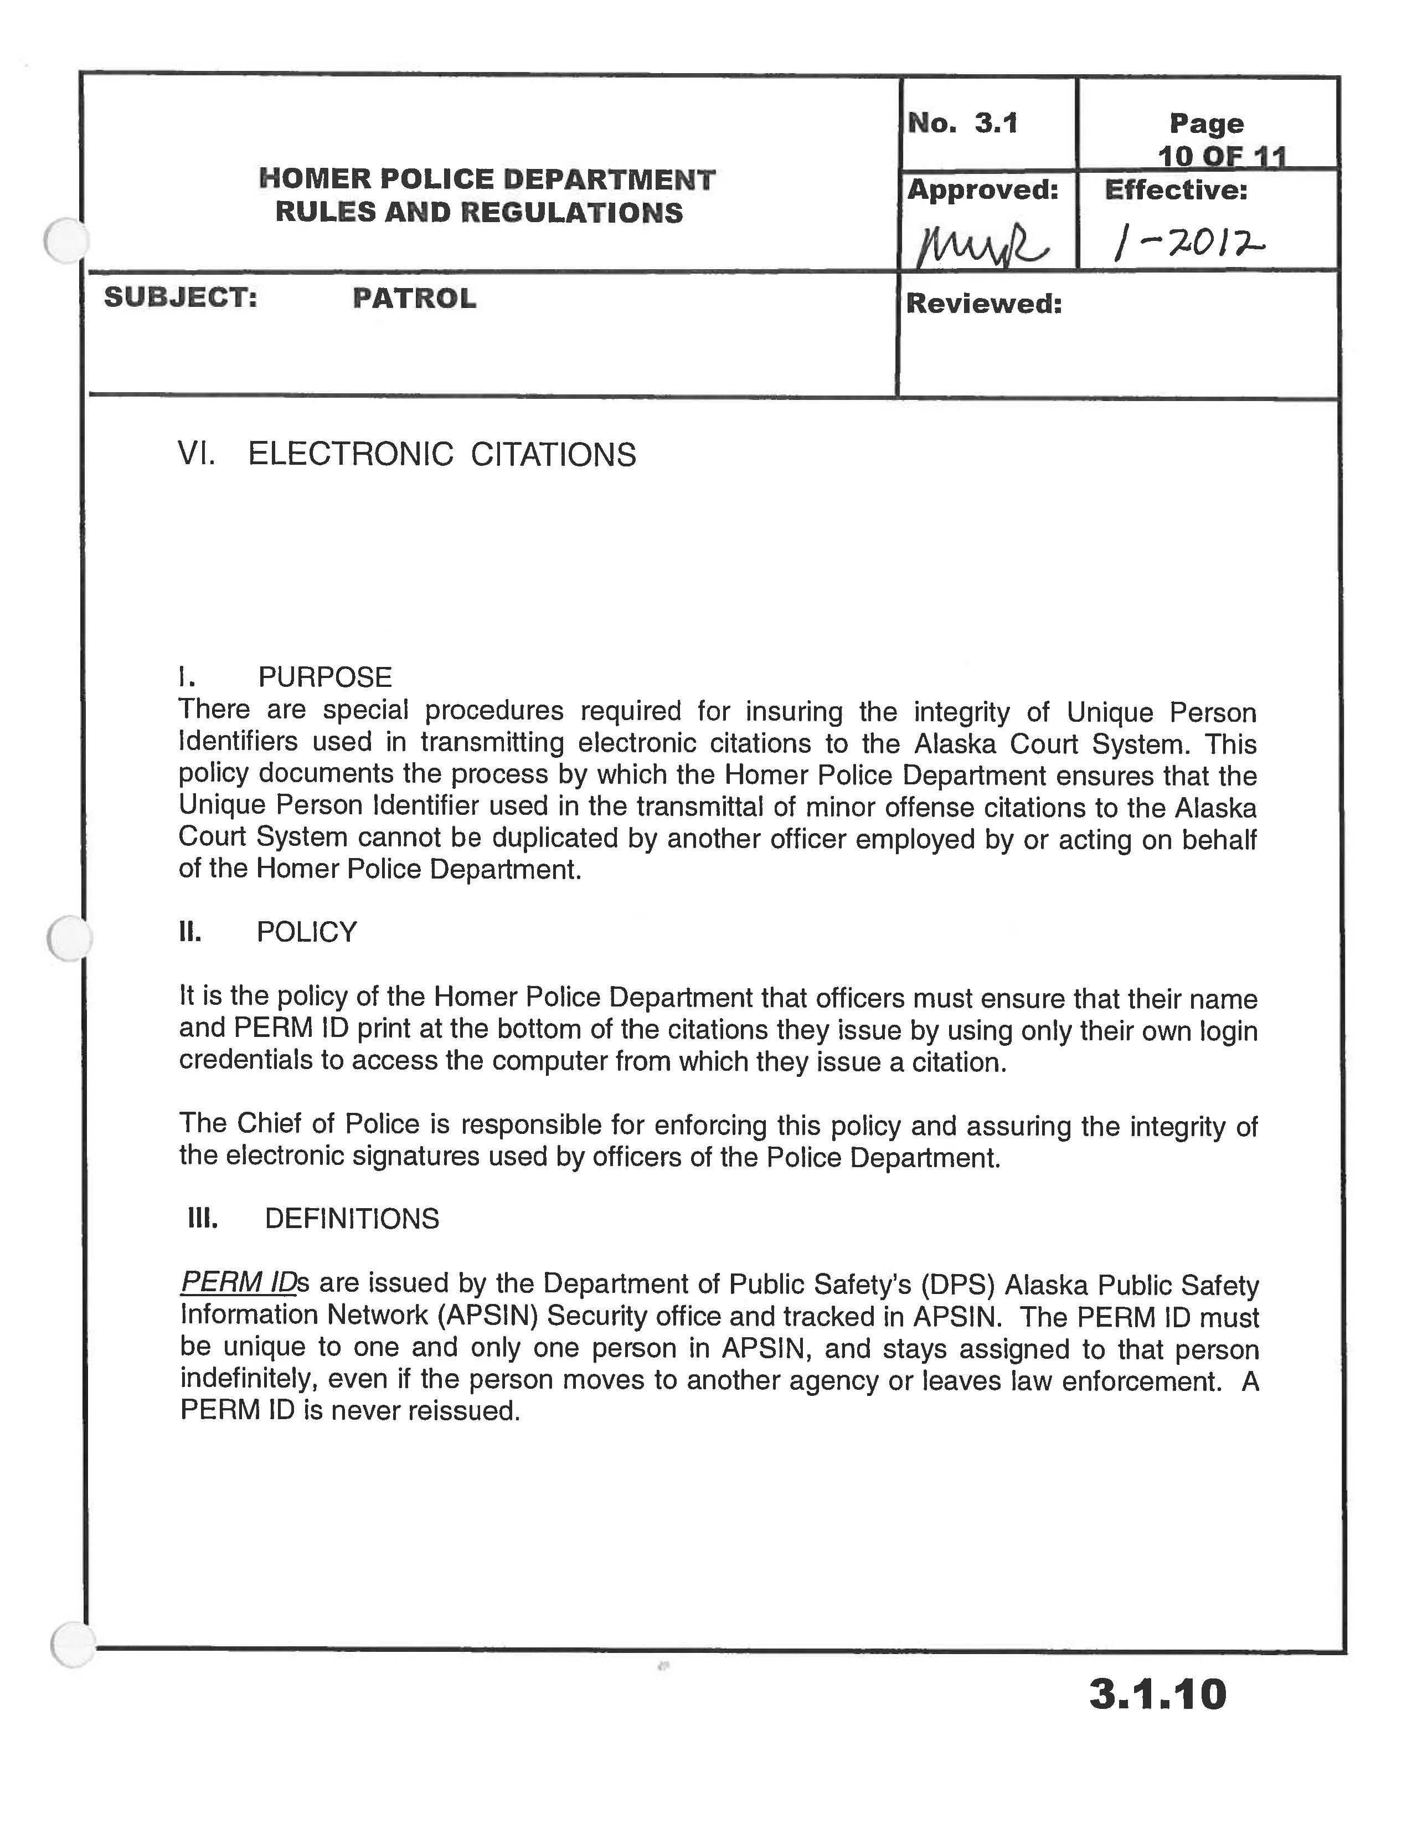

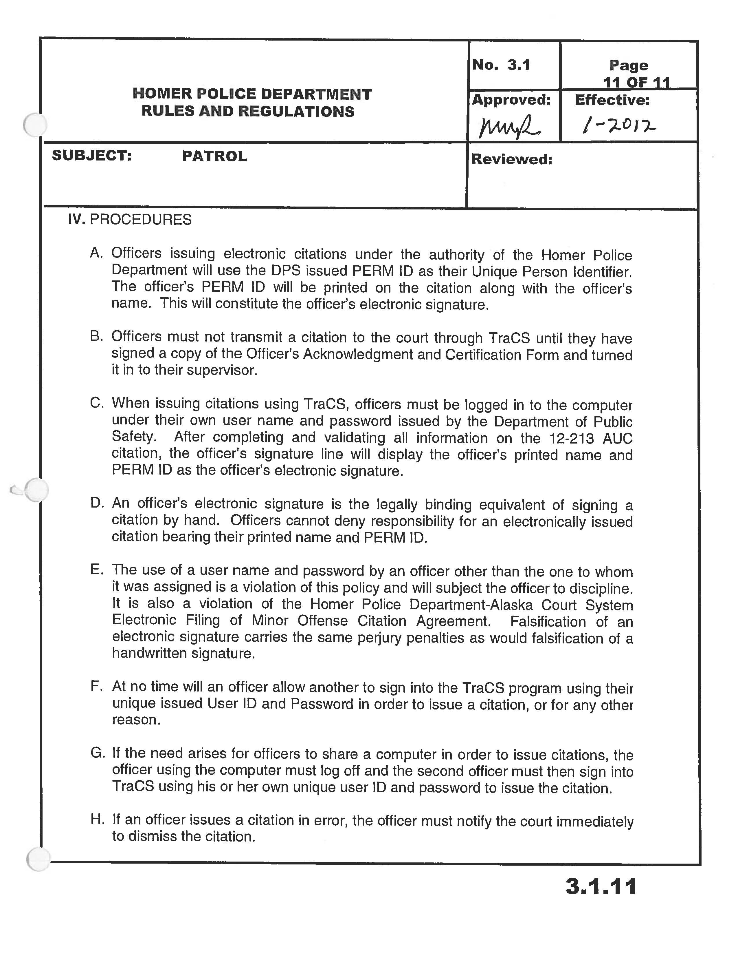

Attachment 2: Agency’s documentation of the process from the creation of the citation through its delivery to the ACS

How TraCS data is secured end to end

Each citation consists of a citation form and citation data collected during a contact. The Agency stores the form (the specific version used during that contact) and all data collected during the contact in a TraCS database. The Agency is responsible for ensuring that citation data is not changed on the officer’s computer during data transfer to the DPS (Department of Public Safety) repository. The DPS has agreed to ensure that the citation data is not changed on the TraCS server and that the reporting system on the TraCS server exactly reconstructs the TraCS citation printed by the officer’s computer (Attachment 5).
The following positions will have access to the electronic citation for purposes of ensuring data integrity: DPS Server Administrators and other authorized DPS IT support staff.

Officer’s Field Reporting Computer System

Operational Integrity
The rules in TraCS are configured so that data is secured and all data entry fields in the 12-213 AUC (Alaska Uniform Citation) Form (other than the APSIN ID number) are locked from editing once the citation has been “issued” (printed). These rules are consistent across all TraCS installations throughout Alaska and cannot be replaced by any files other than those created by the Alaska Department of Public Safety pursuant to Alaska Statute 12.25.175. Once a citation has been issued to a defendant the citation data cannot be altered (except that an APSIN ID number can be added). The DPS will reconstruct a PDF copy of each citation as it was issued by the Agency to the defendant and will make the citation image available to the ACS (See Attachments 4 and 5)
Currently, the rules and TraCS configuration can only be modified by DPS using the TraCS SDK and Global administrative passwords exclusive to Alaska. At this time, these configurations cannot be overridden outside of TraCS.
Data Storage
- All data in the officer’s field reporting computer system is stored in a TraCS proprietary encrypted XML file format (eXML) which cannot be edited outside of the TraCS application. Any attempt to modify the file outside of TraCS would render the file unusable.
- All encrypted TracS data in Workstations are stored in a local Access database.
- If a workstation is shared by more than one TraCS users, each user can only see citations they have created, and do not have access to TraCS citations created by other users of the workstation.

Data Integrity
All data fields required by the ACS on the 12-213 AUC form within TraCS are a part of the form’s data checksum (the method by which the system identifies that data has been altered (SHA-256));

Data Transfer
All TraCS data export functions (End Shift keystroke for an officer’s field reporting computer system or Start Shift keystroke for an officer’s workstation at the officer’s desk) are set to combine all forms into a single encrypted file for each export. The data is encrypted using a 128-bit AES encryption. The encryption key is embedded within the application. The encryption prevents unauthorized access to the data.

DPS’ Repository (System where all TraCS data from the Agency is securely stored within DPS)

The Agency has elected to transfer its citations to the ACS via the DPS repository. By agreement (Attachment 5) the DPS agrees to adhere to the following rules and procedures regarding repository access, operational integrity, data storage, data integrity and data transfer of the Agency’s citation data:

Access
No agency may view or access any other agency’s data or forms in the DPS TraCS data repository without express permission from the data originating agency. The only exception is that the ACS staff will be able to access any citation for the purpose of reprinting.

Operational Integrity
The forms, reports and rules governing the data and data integrity in the DPS statewide TraCS Repository installation are identical to those used in the TraCS client installation.
There are additional rules relating to repository specific functions that do not impact the data.
Data Storage
All citation data in the TraCS repository is stored in an Enterprise SQL Server database. SQL, Windows, and Network security are used to ensure that access to the database is limited to the authorized applications or Database support staff. Database auditing is also enabled for the TraCS data so that any access to the database is logged and any changes made to the data or database structure can be tracked.

The TraCS repository will store all citations issued by all Alaska law enforcement agencies using TraCS. No agency will have the ability to see or access any other agency’s TraCS data unless the issuing agency has granted the other agency explicit permission to do so.

Data Integrity
All fields on the 12-213 AUC within TraCS have a data checksum enabled so that any change in the data outside of the application would be identified within TraCS. DPS will work with the TraCS vendor to ensure equivalent functionality for a stored procedure in SQL Server that enables Data Integrity Monitoring in the statewide TraCS repository outside of the application.
Data Transfer
All data import functions within TraCS are set to decrypt the CZP file submitted by each client export. The same encryption key used by the client is also embedded in the server installation.

Electronic Transfer of the -------------------PD’s TraCS data from the Repository to the ACS

The Department of Public Safety has agreed to provide secure agency to agency transmission to move the ------------------PD’s citation data from the repository in to the ACS’ case management system (Attachment 5). The DPS’ transmission of the Agency’s citation data from the repository is governed by standards approved and provided by the ACS to ensure that the provisions of Section 6.3 Data Integrity are met.

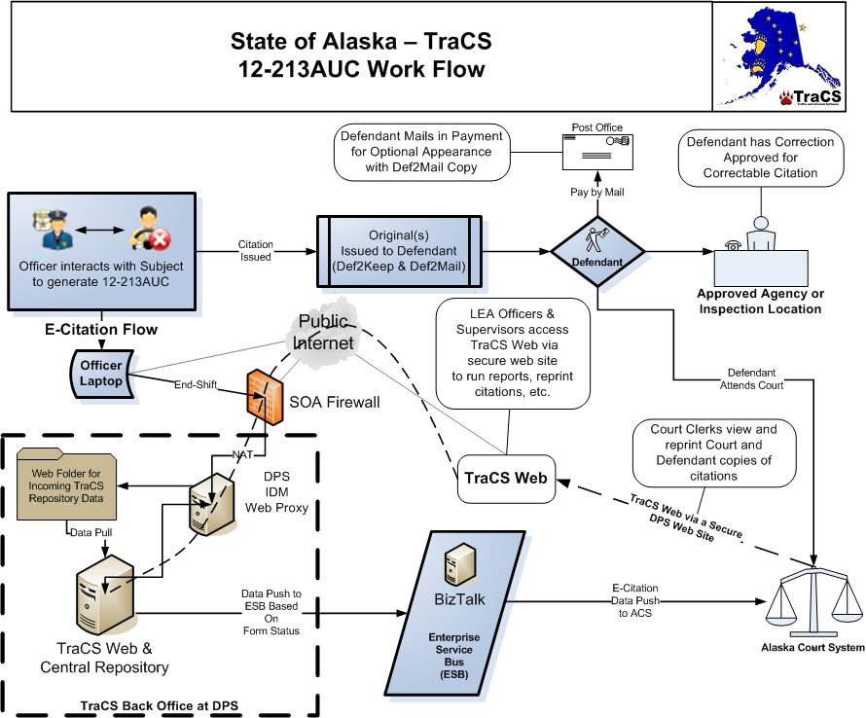

Attachment 3: Acknowledgement, Certification and Signature Form

VALDEZ POLICE DEPARTMENT
P.O. BOX 307
VALDEZ, ALASKA 99686
907-835-4560 (PHONE)
907-834-3412 (FAX)

Officer’s Electronic Signature Acknowledgement and Certification Form

I, ____________________________, certify that I understand that affixing my electronic signature to a citation is the legally binding equivalent of signing the citation by hand, and that I will be bound by that electronic signature. I further understand that the following rules apply to my use of an electronic signature on a citation:

- I will affix my electronic signature to all citations I issue from my electronic device by entering my user name and password to access the electronic device and application.
- I will protect and secure my user account or password and will not share them with any other person, or allow any other person to use that information to sign into the electronic citation device or system.
- If I have any reason to believe that my password or account security may have been compromised, I will notify my agency TraCS Liaison or the Chief of Police immediately.
- I will not issue a citation with another officer’s electronic signature on the document.
- I will not “share” a log-in session. I understand that whoever is logged in must be the officer that issues the citation since it is the electronic signature of the person logged in that will appear on the citation.
- I understand that falsification of an electronic signature carries the same perjury penalties as would falsification of a handwritten signature.

______________________________ ____________________________________
Officer’s Signature Officer’s UPI Date

Attachment 4: Documentation of how the Agency will provide the Alaska Court System with the ability to view an electronic version of the paper citation that the charging officer issued to the defendant.

The Agency agrees that DPS will provide the ACS with access to electronic versions of the paper citations the Agency issued to defendants as follows:

Image Delivery Method

TraCS citations issued by the Agency will be accessible via TraCS Web hosted by DPS. TraCS Web is a web based client for the same TraCS software used by the Agency’s officers when creating citations.

Access to the TraCS Web site is managed by the DPS Web Proxy server and requires authentication.

Availability of TraCS Web

Under normal circumstances TraCS Web will be available 24/7. As with any electronic solution, this availability may be subject to intermittent outages for maintenance or unexpected failures. For scheduled maintenance outages the Agency agrees to provide the ACS and DPS with advanced notification via email.

In the event of a system failure, the Agency agrees to work with DPS to resolve the situation as soon as reasonably possible. During such an outage, the Agency agrees to ensure that copies of citations needed by the Alaska Court System will be made available by contacting the TraCS Support Team at 907-269-5768.

Procedure for accessing electronic image of the citation

1) Request Account Creation
All requests for court clerk access to TraCS Web must be submitted to the TraCS Support Team in advance of the access being required.

Requests should be submitted via email from a designated ACS Administrative Authority to tracs.support@alaska.gov. Once an account is established authorized users will be able to change their website password using a DPS hosted password change site.

The following are needed to create accounts and should be included with each account request:
  - User ID ( First initial, middle initial, and last name)
  - Full Name
  - Job Title
  - Email Address
Upon termination of employment for ACS staff, the ACS will advise the TraCS Support Team via email so the account may be disabled in a timely manner.

2) Access the TraCS Web Site
Login to the TraCS Web site at https://dps.alaska.gov/TraCSWeb using the Username and Password provided by the TraCS Support staff. If a password change is required, you will be redirected to the appropriate password change site.

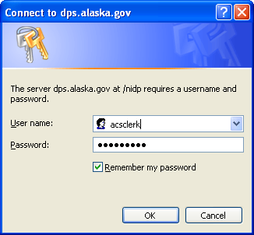
Figure 1

Authenticate to TraCS Web using the TraCS username and password assigned. Currently, this can only be changed by DPS Staff and will not change when the previous password changes.

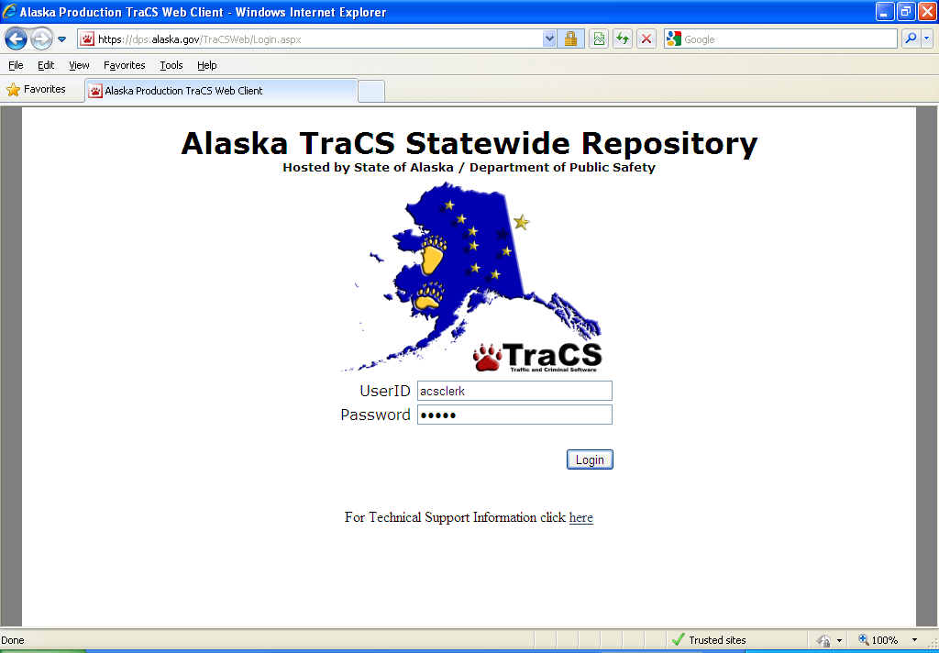
Figure 2

3) Locate Citation
Enter Search criteria in the Form Number field. Search criteria can be the citation number, the last 8 digits of the citation number, or the first 4 characters of the citation number. The user can also search by officer’s name. Click on the Search button.

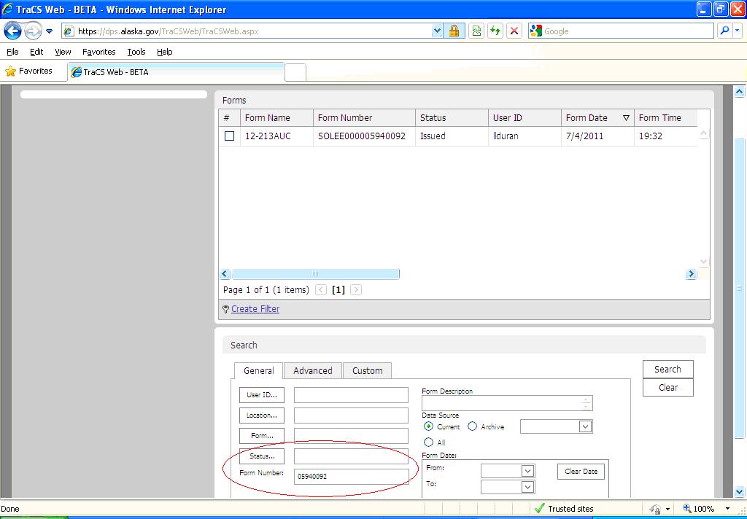
Figure 3

4) Create a PDF to Print or Save a citation
Check the Print checkbox then place the mouse over the Home tab and select Print:

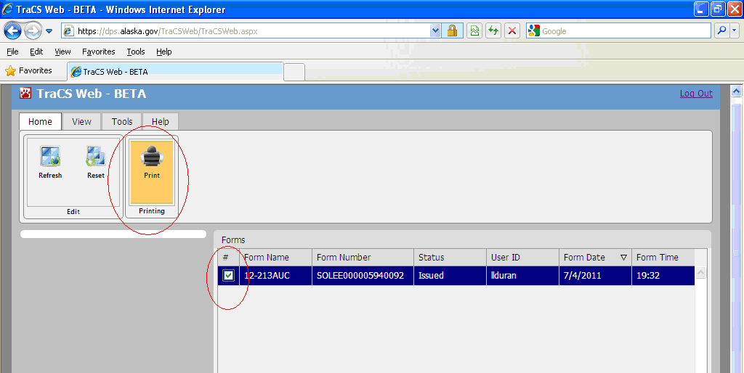
Figure 4

Select the copy you wish to print and then click Print:

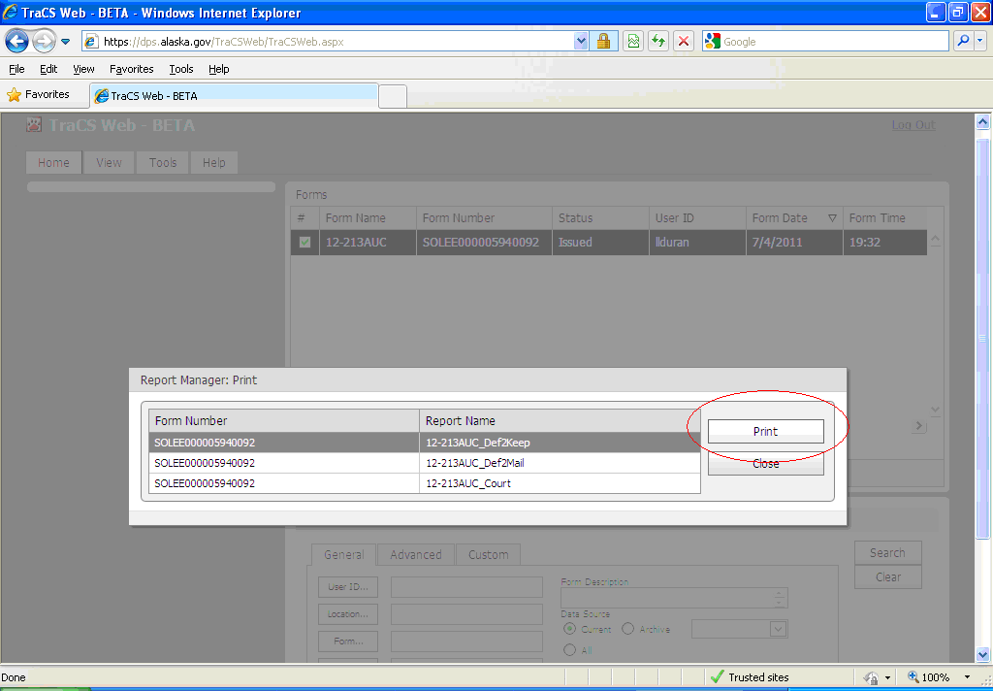
Figure 5

When the PDF copy is displayed, verify the citation is the correct one. Place the mouse over the document and select either the Print or Save icon:

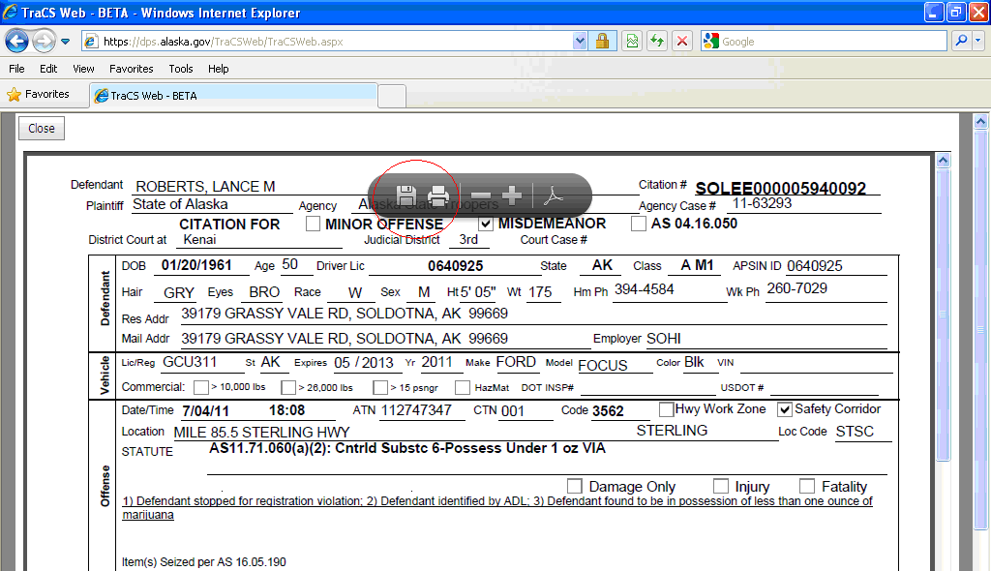
Figure 6

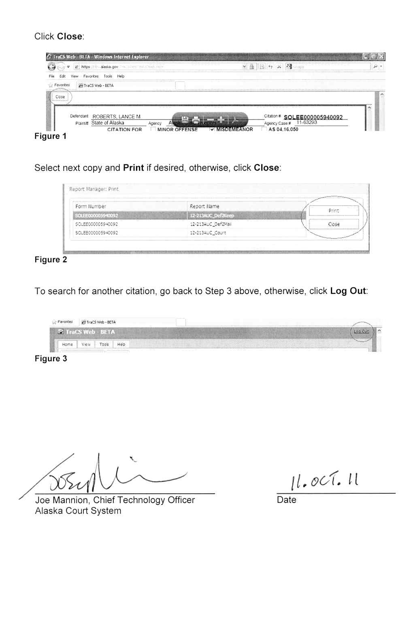

Attachment 5: Memorandum of Agreement between DPS and the ACS for the Electronic Transmittal of Law Enforcement Agency Minor Offense Citations to the Alaska Court System.

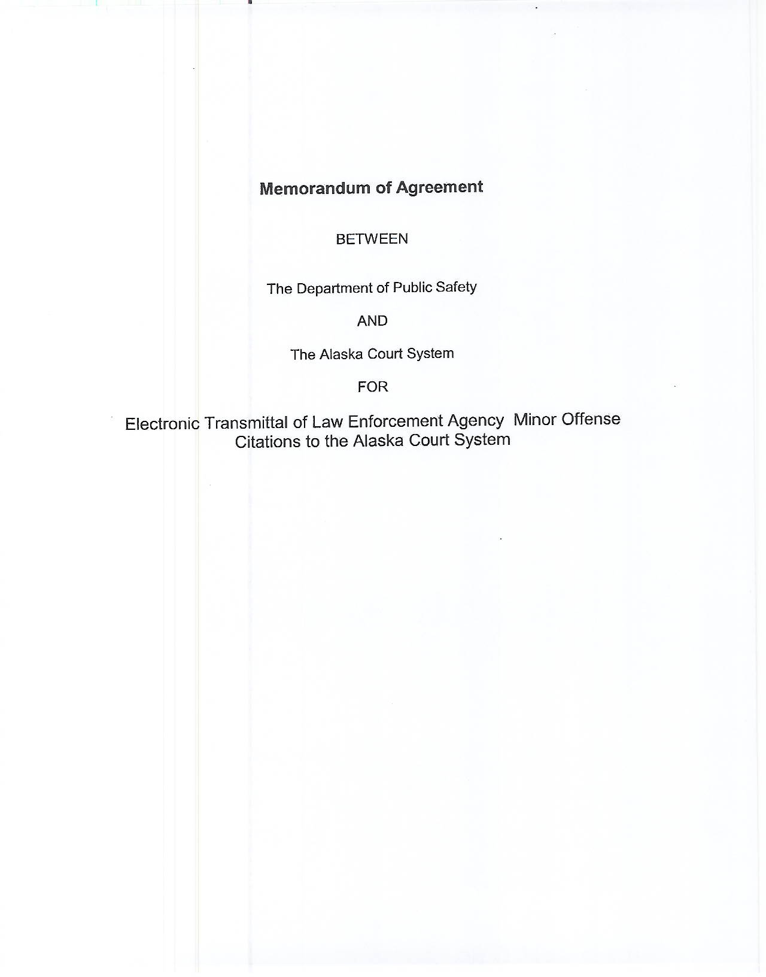

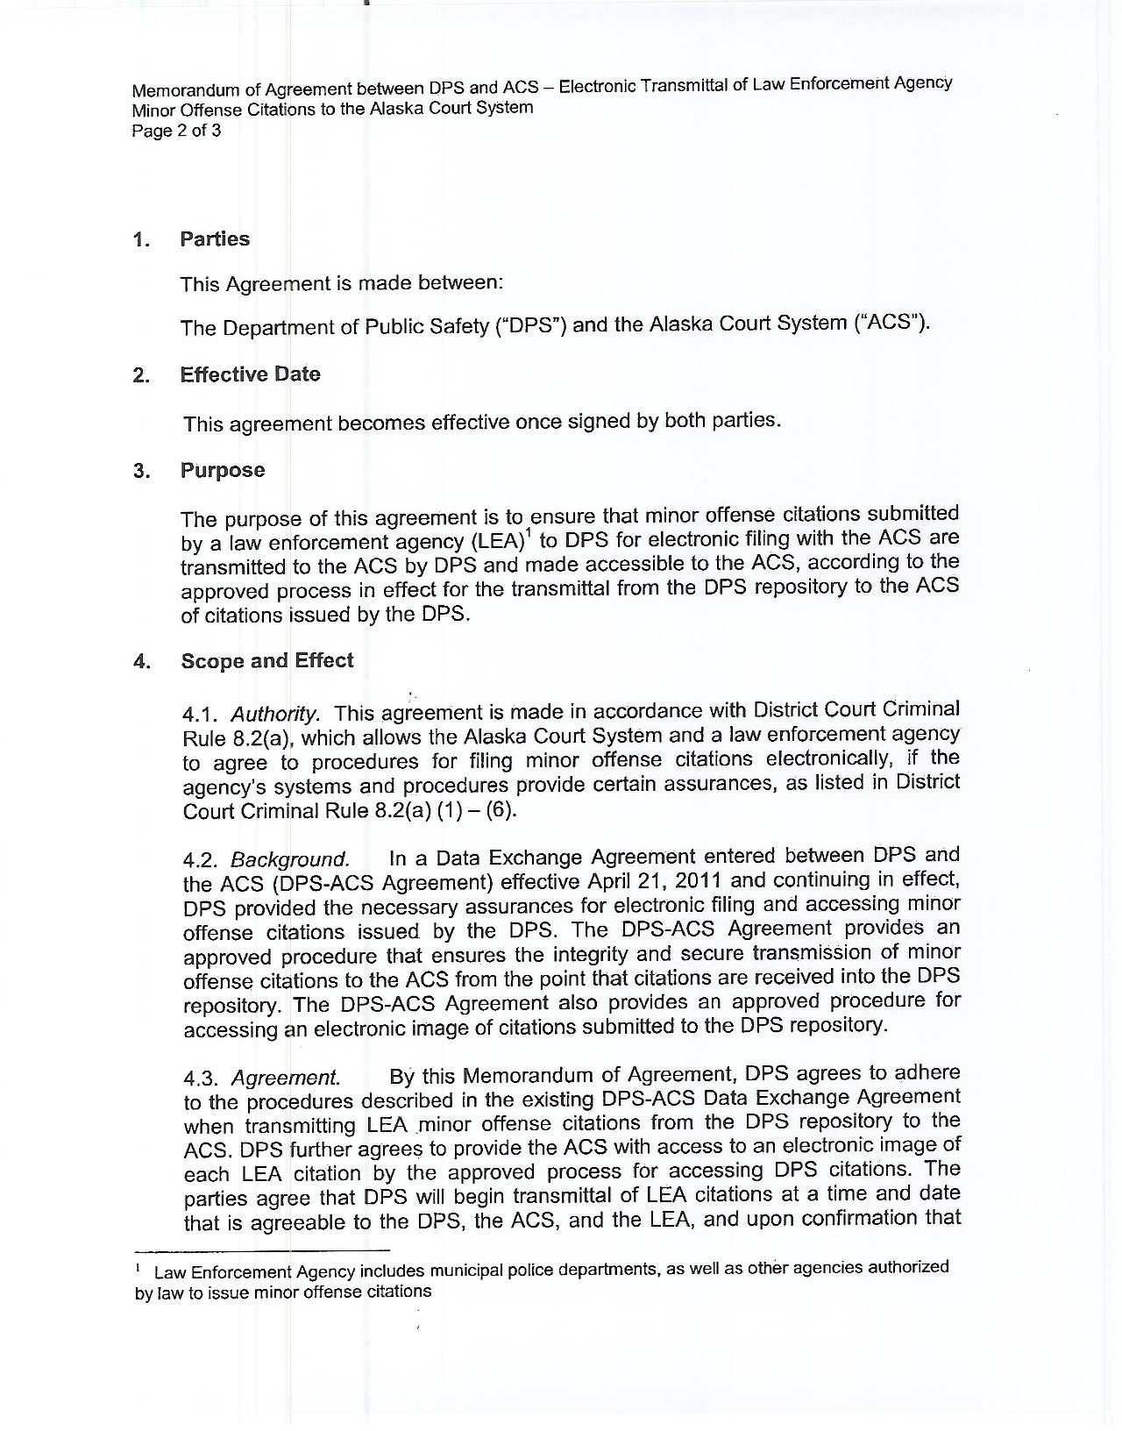

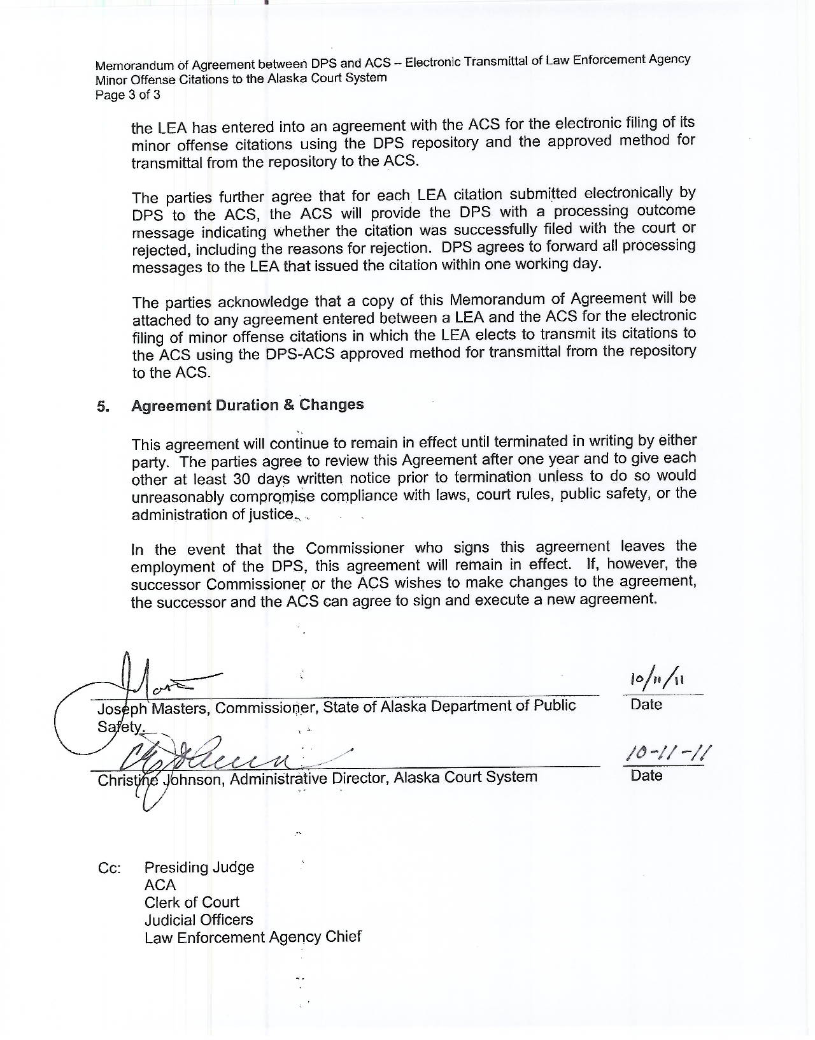

Agency means the agency that employed the officer or person authorized to issue citations or an officer expressly authorized to issue citations on behalf of the agency, who issued the citation on the date the citation was issued.
Unique Person Identifier (UPI) is an identifier that uniquely identifies an officer authorized to issue citations on behalf of the agency.
Officer means peace officer or other official authorized to issue a citation
Authentication is the process of determining whether someone or something is, in fact, who or what it is declared to be.
Nonrepudiation is the ability to ensure that a party to a contract or a communication cannot deny the authenticity of his or her signature on a document or the sending of a message that he or she originated.

