MAJIC Meeting Minutes 2025
Table of Contents

(Click on page number to go directly to minutes for a particular meeting)

February 13, 2025 2
February 27, 2025 4
April 10, 2025 6
June 5, 2025 9
August 14, 2025 12
August 28, 2025 15
September 11, 2025 18
October 23, 2025 22
November 20, 2025 27

MAJIC Meeting

February 13, 2025

- Helen Sharratt | Integrated Justice Coordinator | - Alaska Court System
Lars Johnson | Deputy PD | - Alaska Dept. of Admin, Public Defender
Vacant |  | - Alaska Justice Information Center
Angie Rosales | Victim Witness Coordinator | - Anchorage Municipal Prosecutor’s Office
Josiah Jones, Casey Boe | APD IT Manager | - Anchorage Police Department
- Brian Brossmer | Research Analyst | - Alaska Judicial Council
- Michal Bowers | PBK Coordinator | - Alaska Dept. of Law
VACANT |  | - Alaska DOT, Program Development
Major Steve Adams AWT (Ret) | DPS AWT | - Alaska Association of Chiefs of Police (AACOP)
James Dabbs-Ashworth  - David Muise | Acting DP Manager | - Alaska Dept. of Corrections
Lauren Whiteside  - Wade Long | Driver’s Services | - Alaska DOA/Division of Motor Vehicles
- Tony Piper | ASAP Program Manager | - AK DHSS/Alcohol Safety Action Program (ASAP)
Bridget Grieme | Info System Coord | - Alaska DFCS/Division of Juvenile Justice
- Robert Nave | Protective Svcs Spec | - AK DOH, Division of Health Care Services, Background Check Program
Scott Stair | Investigator | - Alaska Dept., of Revenue, CIU
VACANT | Traffic Records FARS | - Alaska DOT, AK Highway Safety
Lisa Purinton  Kara Southerland | SWS Director  Criminal Justice Planner | - Alaska Dept. of Public Safety, AST
Stephen Mattson | Election Security | - Alaska Division of Elections
- Katherine Stodgell | Public Health Div. Manager | - Municipality of Anchorage (DHHS)
Kaela Watson | Policy and Planning | - AK DOH, Division of Behavioral Health
Chad Holt | Supervising Atty | 21. Alaska Native Justice Center
Joe Bankowski | Special Investigator | 22. AMCO
Junnie Chup | Office Mgt CBJ Law | 23. City & Borough of Juneau – Dept. of Law
Dee Enoch | Database Specialist | 24. Juneau Police Department
Melanie Briggs  Miriam Freas  - Demara Crim | Data Processing Mgt & ORCA Analysts | 25. Alaska DFCS/Office of Children’s Services
Beth Goldstein | Deputy Director | 26. Alaska DOA/Office of Public Advocacy
- Michael Chiesa | Chief Investigator | 27. AK, DEC, Environmental Crimes Unit
OTHER ATTENDEES
Jesse Stringer, DOC | Jamie Ackerschott, DPS | Katherine Wallace, DOA
Amanda Combs, ACS | Carol Scoles, ACS | Anne Fajardo, ACS
Bonnie Hough, ACS | Rachel Crowe, ACS | Dennis Wheeler, MOA
David Bautis, ACS | Melissa Toppin, ACS | Andrew Dougherty, ACS
LOCATION | TEAMS

11:00 - 11:20 a.m.
Alaska Department of Corrections (DOC) 2023 Offender Profile. Prepared January 1, 2024. Trends, Counts & Percentages. Jesse Stringer, Budget Analyst III, Alaska Department of Corrections (DOC) provided an overview of the report and trends. The report can be found here:
https://doc.alaska.gov/offenderprofile.pdf

This report leverages data visualization techniques to provide clear and accessible information at-a-glance. This report provides data that policy makers and the legislature need to make decisions. The disproportionate number of Alaska Native incarcerated individuals is a salient issue now under review pursuant to HB 66. Recently noted trends include an increase in the unsentenced population and an increase in age. The report is published annually. The 2024 report will be published in the near future. Past reports from 2002 onwards can be found on the DOC website’s research page.

11:20 - 11:40 a.m.
Alaska Code Tables (ACT). A Standardized Table of Data Fields for Specific Case Type Exchanges with the Alaska Court System (the ACS).

The ACS provided an overview of the ACT which now formalizes ACS-required offense code standards for data exchanges. These standards are already followed for the most part by partner agencies for criminal and minor offense data sharing. The ACS shared the Guide to the ACT. This document defines and describes the required format for building exchanges with the ACS for criminal and minor offense case types.

Expansion of the ACT to include other case types should be anticipated and the Guide will be updated accordingly. Work is underway to integrate the ACT within the ACS’ document management system to validate incoming charges filed with the ACS. The ACT itself, which is still under review and being refined, updates daily. Links to both the ACT and the Guide will be published on the MAJIC website under the projects tab.

11:40 a.m. - 12 noon.
Efile Update. Amanda Combs, Project Manager, provided an update on the eFile project and reminded agencies of the upgrade this weekend during which the eFile portal would be unavailable until late Saturday or early Sunday.

Criminal and Minor Offense eFile are now mandatory statewide. The help and support of agencies in achieving this has been greatly appreciated by the ACS eFile team. Work continues to enhance criminal and minor offense case processing, but attention is also now turning to civil eFile. It is anticipated that all courts except Anchorage and Palmer will go live with civil case type eFile (except delinquency, probate, and CINA) this summer. Anchorage and Palmer will go live in the Fall.

February 27, 2025

- Helen Sharratt | Integrated Justice Coordinator | - Alaska Court System
Lars Johnson | Deputy PD | - Alaska Dept. of Admin, Public Defender
Vacant |  | - Alaska Justice Information Center
Angie Rosales | Victim Witness Coordinator | - Anchorage Municipal Prosecutor’s Office
Josiah Jones, Casey Boe | APD IT Manager | - Anchorage Police Department
Brian Brossmer | Research Analyst | - Alaska Judicial Council
- Michal Bowers | PBK Coordinator | - Alaska Dept. of Law
VACANT |  | - Alaska DOT, Program Development
Major Steve Adams AWT (Ret) | DPS AWT | - Alaska Association of Chiefs of Police (AACOP)
- James Dabbs-Ashworth  - David Muise | Acting DP Manager | - Alaska Dept. of Corrections
Lauren Whiteside | Driver’s Services | - Alaska DOA/Division of Motor Vehicles
Tony Piper | ASAP Program Manager | - AK DHSS/Alcohol Safety Action Program (ASAP)
- Bridget Grieme | Info System Coord | - Alaska DFCS/Division of Juvenile Justice
- Robert Nave | Protective Svcs Spec | - AK DOH, Division of Health Care Services, Background Check Program
Scott Stair | Investigator | - Alaska Dept., of Revenue, CIU
VACANT | Traffic Records FARS | - Alaska DOT, AK Highway Safety
Lisa Purinton  - Kara Southerland | SWS Director  Criminal Justice Planner | - Alaska Dept. of Public Safety, AST
Stephen Mattson | Election Security | - Alaska Division of Elections
- Katherine Stodgell | Public Health Div. Manager | - Municipality of Anchorage (DHHS)
Kaela Watson | Policy and Planning | - AK DOH, Division of Behavioral Health
Chad Holt | Supervising Atty | 21. Alaska Native Justice Center
Joe Bankowski | Special Investigator | 22. AMCO
Junnie Chup | Office Mgt CBJ Law | 23. City & Borough of Juneau – Dept. of Law
Dee Enoch | Database Specialist | 24. Juneau Police Department
Melanie Briggs  Miriam Freas  Demara Crim | Data Processing Mgt & ORCA Analysts | 25. Alaska DFCS/Office of Children’s Services
Beth Goldstein | Deputy Director | 26. Alaska DOA/Office of Public Advocacy
Michael Chiesa | Chief Investigator | 27. AK, DEC, Environmental Crimes Unit
OTHER ATTENDEES
Karen Hall, ACP Program, Michigan | Anne Fajardo, ACS
Ina Mano, ACS | Andrew Dougherty, ACS
Paula Davis, DPS | Rachel Crowe, ACS
David Bautis, ACS | Melissa Toppin, ACS
LOCATION | TEAMS

11 a.m. to 12:00 noon.

The Michigan Address Confidentiality Program (ACP).

In December 2020, Michigan’s Governor Whitmer signed the Address Confidentiality Program Act, Act 301 of 2020 (MCL 780.851 et seq.) The Program was created to provide certain protections for victims of domestic violence, sexual assault, stalking, human trafficking, and others who fear that disclosure of their physical address will increase their risk of harm. While 44 other states and the District of Columbia have laws pertaining to an Address Confidentiality Program, Michigan’s ACP solution is the only one in the nation to allow participants to manage their data via an online portal.

Karen Hall, Program Manager, Michigan Address Confidentiality Program, Michigan Department of Attorney General provided a detailed presentation of the program. Karen shared the Power Point presentation slides following the meeting and authorized their distribution to MAJIC members.

The Michigan ACP protects an eligible participant’s real address by providing a legal substitute address and a mail forwarding service for all first class, registered, and certified mail. Third class mail and packages are not included. All state and local government agencies are required by law to accept and use the substitute address when requested by a participant. The Secretary of State is required to issue driver’s licenses and state IDs for accepted applicants without their residential address. The confidential address is also protected from disclosure in elections, and participants can also be exempted from jury duty. Federal agencies and private entities are not legally required to use the substitute address.

Eligible persons not only include victims of domestic violence, stalking, sexual assault and human trafficking, but also any person who is at risk of being threatened or physically harmed if their real address is revealed. Applicants must Michigan residents, be moving or planning to move, be 18 years or older, an emancipated minor, or a parent or guardian acting on behalf of a minor or ward. Applicants do not have to be US citizens.

Persons on the sex offender registry, or persons who already have provided their confidential address to the Secretary of State are not eligible.

Law enforcement can get access to an ACP participant’s confidential address for exigent circumstances by contacting the Michigan State Police.

The ACP application is part of a Software as a Service (SaaS) solution using Power Platform in the Microsoft Azure Government Community Cloud. End-to-end case management is provided from initial application, to approval or denial, and continued participation/renewal. ACP staff also use this system to send notifications to participants and advocates, generate documents, audit transactions, and manage advocate training and certification.

April 10, 2025

- Helen Sharratt | Integrated Justice Coordinator | - Alaska Court System
Lars Johnson | Deputy PD | - Alaska Dept. of Admin, Public Defender
Vacant |  | - Alaska Justice Information Center
Angie Rosales | Victim Witness Coordinator | - Anchorage Municipal Prosecutor’s Office
- Casey Boe | APD IT Manager | - Anchorage Police Department
Brian Brossmer | Research Analyst | - Alaska Judicial Council
Michal Bowers | PBK Coordinator | - Alaska Dept. of Law
VACANT |  | - Alaska DOT, Program Development
Major Steve Adams AWT (Ret) | DPS AWT | - Alaska Association of Chiefs of Police (AACOP)
- James Dabbs-Ashworth  David Muise | Acting DP Manager | - Alaska Dept. of Corrections
Lauren Whiteside | Driver’s Services | - Alaska DOA/Division of Motor Vehicles
- Tony Piper | ASAP Program Manager | - AK DHSS/Alcohol Safety Action Program (ASAP)
Bridget Grieme | Info System Coord | - Alaska DFCS/Division of Juvenile Justice
Robert Nave | Protective Svcs Spec | - AK DOH, Division of Health Care Services, Background Check Program
Scott Stair | Investigator | - Alaska Dept., of Revenue, CIU
VACANT | Traffic Records FARS | - Alaska DOT, AK Highway Safety
- Lisa Purinton  - Kara Southerland | SWS Director  Criminal Justice Planner | - Alaska Dept. of Public Safety, AST
Stephen Mattson | Election Security | - Alaska Division of Elections
- Katherine Stodgell | Public Health Div. Manager | - Municipality of Anchorage (DHHS)
Kaela Watson | Policy and Planning | - AK DOH, Division of Behavioral Health
Chad Holt | Supervising Atty | 21. Alaska Native Justice Center
Joe Bankowski | Special Investigator | 22. AMCO
Junnie Chup | Office Mgt CBJ Law | 23. City & Borough of Juneau – Dept. of Law
Dee Enoch | Database Specialist | 24. Juneau Police Department
Melanie Briggs  Miriam Freas  Demara Crim | Data Processing Mgt & ORCA Analysts | 25. Alaska DFCS/Office of Children’s Services
Beth Goldstein | Deputy Director | 26. Alaska DOA/Office of Public Advocacy
- Michael Chiesa | Chief Investigator | 27. AK, DEC, Environmental Crimes Unit
OTHER ATTENDEES
Tracy Frable, APD | Anne Fajardo, ACS | Bonnie Hough, ACS
Ina Mano, ACS | Andrew Dougherty, ACS | Carol Scoles, ACS
Paula Davis, DPS | Rachel Crowe, ACS | Sharon Chen, ACS
David Bautis, ACS | Melissa Toppin, ACS | Ted Johnston, DPS
Joe Waters, DPS | Elena Tuohey, DPS | Jamie Ackerschott, DPS
LOCATION | TEAMS

11:00 – 11:30 a.m.
APSIN Character Length Change. As part of the Department of Public Safety’s ongoing project to modernize its Criminal Justice Information Systems (CJIS-M), the character length of the APSIN identification number will be expanded. The current system-generated number is also close to capping out at 9999999 which is necessitating the need to expand the character length.

Lisa Purinton, Statewide Services Director and staff from the Department of Public Safety provided an overview of the five-year CJIS Modernization (CJIS-M) Project and the anticipated changes to the APSIN ID number.

DPS is working with five different vendors on a complex project to move from the legacy mainframe to a modern framework and system. As the project enters its fifth year, DPS is working closely with stakeholders and sharing with them any changes that could impact systems. The tentative go-live date is December 2025 – January 2026, and will depend on finalizing key steps. At present, DPS is getting ready to start integration and User Acceptance Testing (UAT).

The change to the APSIN ID is one aspect of this project. Endorsed by MAJIC as Alaska’s unique person identifier, the APSIN ID is used by all Alaska’s criminal justice agencies as a uniform key data point to track persons through the system. The APSIN ID is 7 characters, but must be expanded to 8 characters when DPS cuts over to the new system. The 8 characters will be numerical only. Alpha AK is only added for transmission to the FBI. Zero padding will be included. All agency systems will need to be able to accommodate this expansion. DPS will coordinate with agencies and give plenty of notice before cutover occurs. The new field length will be backwards compatible. The new number range will not be issued until DPS goes live with the new system.

Notice of this change has gone out to all stakeholders including TACs and LASOs. Work will be undertaken with Live Scan machines to accommodate the APSIN ID expansion. Testing will be undertaken with partner agencies such as Law, DOC, and the ACS ahead of the cut over. At least one mock go-live for the new system is going to be scheduled and agencies will be able to test with DPS. For agencies that query APSIN to audit APSIN data, such as the ACS, the web service DPS will provide can be used to create a test record to query and check compatibility ahead of cutover.

There will also be some changes to the Uniform Offense Code Table (UOCT) which houses all criminal offenses and is maintained and managed by DPS. The MS Access legacy format will be discontinued. Agencies will need to confirm that this will not be an issue. This change will be communicated to agencies, and a banner will also be placed on the UOCT webpage.

These changes are to accommodate additional data needed by DPS such as sex offender registration and DNA requirements, and will not affect the way agencies download the UOCT. The changes also include expansion of the literal description field for the offense. This was previously limited to 45 characters. The literal description field will now be set to allow a maximum of 300 characters, which will make it less challenging to ascertain the nature of the conviction.

Lisa provided information on the upcoming historical protective order repository sub-project. DPS is statutorily required to maintain a repository of protective orders (POs), some of which have conditions that do not expire until the order is dissolved. These must go into the NICS. The PO repository will be a module within the new system. The legacy system stores the full body and content of POs, but that will go away. The new module will allow officers in the field to quickly identify the conditions (no contact, etc.). There is interest at DPS in having a link to a PDF document of the PO through the API that DPS and the ACS are working on currently.

The officer unique identification number (PERM ID) will be managed in the state trooper’s RMS (ARMS).

11:30 – 11:45 a.m.
eFile Update. Ina Mano, Project Manager provided an update on the timeline for the upcoming civil case type roll out. It is anticipated that all courts except Anchorage and Palmer will go live on June 16, 2025 for civil and small claims. CINA and Probate will not be going live until late 2026. Delinquency will follow. It is hoped that all case types will be rolled out by 2027.

TrueFiling will not be available for civil filers the week preceding go live, and a message will go out about this. Training will commence May 19.

June 5, 2025

- Helen Sharratt | Integrated Justice Coordinator | - Alaska Court System
Lars Johnson | Deputy PD | - Alaska Dept. of Admin, Public Defender
Vacant |  | - Alaska Justice Information Center
Angie Rosales | Victim Witness Coordinator | - Anchorage Municipal Prosecutor’s Office
- Casey Boe | APD IT Manager | - Anchorage Police Department
Brian Brossmer | Research Analyst | - Alaska Judicial Council
- Michal Bowers | PBK Coordinator | - Alaska Dept. of Law
VACANT |  | - Alaska DOT, Program Development
Sean Case | AACOP President | - Alaska Association of Chiefs of Police (AACOP)
- James Dabbs-Ashworth  David Muise | Acting DP Manager | - Alaska Dept. of Corrections
Lauren Whiteside | Driver’s Services | - Alaska DOA/Division of Motor Vehicles
- Tony Piper | ASAP Program Manager | - AK DHSS/Alcohol Safety Action Program (ASAP)
Bridget Grieme | Info System Coord | - Alaska DFCS/Division of Juvenile Justice
Robert Nave | Protective Svcs Spec | - AK DOH, Division of Health Care Services, Background Check Program
Scott Stair | Investigator | - Alaska Dept., of Revenue, CIU
VACANT | Traffic Records FARS | - Alaska DOT, AK Highway Safety
- Lisa Purinton  - Kara Southerland | SWS Director  Criminal Justice Planner | - Alaska Dept. of Public Safety, AST
Phillip Malander |  | - Alaska Division of Elections
Katherine Stodgell | Public Health Div. Manager | - Municipality of Anchorage (DHHS)
Kaela Watson | Policy and Planning | - AK DOH, Division of Behavioral Health
Chad Holt | Supervising Atty | 21. Alaska Native Justice Center
Joe Bankowski | Special Investigator | 22. AMCO
Junnie Chup | Office Mgt CBJ Law | 23. City & Borough of Juneau – Dept. of Law
- Dee Enoch | Database Specialist | 24. Juneau Police Department
Melanie Briggs  Miriam Freas  - Demara Crim | Data Processing Mgt & ORCA Analysts | 25. Alaska DFCS/Office of Children’s Services
Beth Goldstein | Deputy Director | 26. Alaska DOA/Office of Public Advocacy
Michael Chiesa | Chief Investigator | 27. AK, DEC, Environmental Crimes Unit
OTHER ATTENDEES
Sean Case, APD Chief | Anne Fajardo, ACS | Bonnie Hough & CMS staff ACS
Ina Mano, ACS | Paula Davis, DPS | Justin Bode, DPS
Amanda Combs, ACS eFile PM | Teri Carns, AJC | Gail Campbell, DPS
Case Mohr, ACS | Stacey Marz, ACS | Kathleen Wallace, DMV
Harrison MacRae, Speaker PA | Kate Lampert, DMV | Jamie Ackerschott, DPS
LOCATION | TEAMS

11:00 a.m. - Noon
Pennsylvania’s pilot Generative AI Program for state government work.

Harrison MacRae, Director of Emerging Technologies for the Commonwealth of Pennsylvania presented Pennsylvania’s pilot Generative AI Program.

In 2024, the Commonwealth of Pennsylvania launched a pilot program to explore how generative AI tools like ChatGPT could support government work. Harrison provided an overview and highlighted key takeaways from the pilot, including how employees used AI in their day-to-day tasks, the range of user experiences, adoption patterns that emerged, and the most common barriers to effective use. The presentation provided valuable information on what worked, what didn't, and how these lessons will inform Pennsylvania's next steps for responsible AI integration across state agencies.

Harrison provided the following link to the full report on the pilot:
https://www.pa.gov/content/dam/copapwp-pagov/en/oa/documents/programs/information-technology/documents/openai-pilot-report-2025.pdf

The year-long pilot aimed to provide greater understanding of how Gen AI would function in the context of Pennsylvania’s workforce. Employees selected to participate in the pilot represented different ages and job functions, at multiple state agencies. The feedback was positive, and significant efficiencies were gained. The pilot confirmed that Gen AI is not a substitute for the nuance and experience employees bring to their work: the human in the loop is critical. No singular profile of a successful user emerged. A wide range of employees over 14 departments identified both opportunities and challenges with adopting Gen AI to support their work.

The pilot was structured to provide training and support for participants, with regular check-ins throughout the year. The organizers held weekly office hours, small group problem scoping sessions, and conducted surveys. The most common use cases were writing and research, coding, and new ways to problem solve.

The analysis of task complexity revealed that tasks initially viewed as moderately complex were simplified through the use of Chat GPT. Workers reported that many of their tasks became more manageable. Data on the corrections needed following the application of Gen AI to a task showed that nuance edits were the most common. Bias, hallucinations, and inaccuracies were also reported, but most corrections involved the need to provide the worker’s own nuance and expertise.

Barriers to use included loss of trust when initial output was inaccurate, habit, lack of learning and familiarity, a steep learning curve, and doubts about the validity of the data. Knowing how to define a prompt and application to specific tasks were also reported as challenges.

The pilot used an enterprise specific version of Chat GPT, not the free model. That really helped with ensuring workers adhered to policies prohibiting the use of PII, CJIS, HIPAA or other sensitive data. If using a bespoke AI tool, running it through IT security is a critical step.

It is also critical to reinforce with workers that they alone are responsible for their work product and that verification is always required. How best to train on verification, and ensuring work product is accurate is still a work in progress for PA team. Workers must be reminded that Gen AI is not a short cut, must be used prudently, and all output must be carefully reviewed for accuracy, completeness, and nuance.

Going forward Pennsylvania will use the experiences and observations that emerged from the pilot to inform efforts to create pathways for use beyond the pilot participants, and to set workers up for success by providing resources, training and support.

August 14, 2025

- Helen Sharratt | Integrated Justice Coordinator | - Alaska Court System
Lars Johnson | Deputy PD | - Alaska Dept. of Admin, Public Defender
Vacant |  | - Alaska Justice Information Center
Angie Rosales | Victim Witness Coordinator | - Anchorage Municipal Prosecutor’s Office
Tracy Frable | APD Records | - Anchorage Police Department
Brian Brossmer | Research Analyst | - Alaska Judicial Council
Michal Bowers | PBK Coordinator | - Alaska Dept. of Law
VACANT |  | - Alaska DOT, Program Development
- Sean Case | AACOP President | - Alaska Association of Chiefs of Police (AACOP)
- James Dabbs-Ashworth  David Muise | Acting DP Manager | - Alaska Dept. of Corrections
Lauren Whiteside | Driver’s Services | - Alaska DOA/Division of Motor Vehicles
- Tony Piper | ASAP Program Manager | - AK DHSS/Alcohol Safety Action Program (ASAP)
Bridget Grieme | Info System Coord | - Alaska DFCS/Division of Juvenile Justice
Robert Nave | Protective Svcs Spec | - AK DOH, Division of Health Care Services, Background Check Program
Scott Stair | Investigator | - Alaska Dept., of Revenue, CIU
VACANT | Traffic Records FARS | - Alaska DOT, AK Highway Safety
Lisa Purinton  Kara Southerland | SWS Director  Criminal Justice Planner | - Alaska Dept. of Public Safety, AST
Phillip Malander |  | - Alaska Division of Elections
Katherine Stodgell | Public Health Div. Manager | - Municipality of Anchorage (DHHS)
Kaela Watson | Policy and Planning | - AK DOH, Division of Behavioral Health
Chad Holt | Supervising Atty | 21. Alaska Native Justice Center
Kevin Richard/  Joe Bankowski | Director/ Special Investigator | 22. AMCO
Junnie Chup | Office Mgt CBJ Law | 23. City & Borough of Juneau – Dept. of Law
Dee Enoch | Database Specialist | 24. Juneau Police Department
- Melanie Briggs  Miriam Freas  - Demara Crim | Data Processing Mgt & ORCA Analysts | 25. Alaska DFCS/Office of Children’s Services
Beth Goldstein | Deputy Director | 26. Alaska DOA/Office of Public Advocacy
- Michael Chiesa | Chief Investigator | 27. AK, DEC, Environmental Crimes Unit
OTHER ATTENDEES
Case Mohr, ACS | Anne Fajardo, ACS | Bonnie Hough
Rebecca Koford, ACS | Melissa Toppin, ACS | Mara Rabinowitz, ACS
Amanda Combs, ACS eFile PM | David Bautis, ACS | Carol Scoles, ACS
Andy Dougherty, ACS | Phillip Drennan, ACS | Hanley Robinson, ACS
LOCATION | TEAMS

11:00 a.m. - Noon
Administrative Attorneys Case Mohr and Rebecca Koford presented Artificial Intelligence and the Alaska Court System (ACS).

AI is now routinely used by us all, whether we are aware of it or not. AI is picking up steam and increasingly working its way into products and software. The ACS decided it was important to get a policy in place to set expectations and clearly lay out responsibilities and requirements for court staff. AI should be viewed as a tool. Like any specialized tool, proper use is required to avoid risks. Even in businesses and organizations that discourage or limit the use of AI, it could be being used, with all the vulnerabilities inherent in not having clear guidance in place. By getting out ahead, the ACS’ policy will promote the importance of staff accountability and prevent misuse. The ACS is also working on a training component to go with the policy.

The ACS looked at other states and court policies. About 12 other court systems have developed a policy and the ACS reviewed all of them. Approaches among courts ranged from very strict to permissive. The ACS has taken a permissive approach, but with clearly defined and strict requirements.

Case reviewed the policy. Responsibility and confidentiality are core to the ACS’ policy. The importance of verification and good judgment are also emphasized.

The policy makes clear that the employee is solely responsible for their work product. If an employee uses AI to write an email, the email must be carefully reviewed to ensure it is accurate and appropriate before it is sent. The sender is accountable for any errors. A human must always be in the loop – verification, correction, judgment, and thoroughness are critical. All use must comply with court rules and policies.

Staff are prohibited from using confidential information or personally identifiable information to generate work with AI. In-house private AI programs are expensive. Free programs may use prompts, even those containing confidential information, to train their systems and accidentally make the information available to the public. The policy is clear that staff must not use personal, or confidential information in a prompt. Employees are reminded they should only enter information appropriate for disclosure to the public.

Case provided examples of how AI can be used in daily tasks such as agenda, emails, letters, job postings, and image creation. By crafting a clear, direct prompt with the end result in mind, employees can generate drafts which must then be carefully reviewed for errors and tone.

eFile Update.
Amanda Combs, Project Manager provided an update on the timeline for the upcoming Civil and Small Claims roll out which includes protective orders. Palmer goes live on August 18, 2025. Anchorage, Sand Point, and Saint Paul will go live on September 22, 2025. An Introduction to TrueFiling will be held on September 12, 2025 via Zoom. The Zoom link can be here https://courts.alaska.gov/efile/index.htm This training may also be a useful refresher for all eFilers. CLE credit is available from the Alaska Bar Association. All remaining case types (Delinquency, CINA, and Probate) are tentatively scheduled to roll out by January 2027.

August 28, 2025

- Helen Sharratt | Integrated Justice Coordinator | - Alaska Court System
Lars Johnson | Deputy PD | - Alaska Dept. of Admin, Public Defender
Vacant |  | - Alaska Justice Information Center
Angie Rosales | Victim Witness Coordinator | - Anchorage Municipal Prosecutor’s Office
Tracy Frable | APD Records | - Anchorage Police Department
Brian Brossmer | Research Analyst | - Alaska Judicial Council
Michal Bowers | PBK Coordinator | - Alaska Dept. of Law
VACANT |  | - Alaska DOT, Program Development
Sean Case | AACOP President | - Alaska Association of Chiefs of Police (AACOP)
- James Dabbs-Ashworth  David Muise | Acting DP Manager | - Alaska Dept. of Corrections
Lauren Whiteside | Driver’s Services | - Alaska DOA/Division of Motor Vehicles
Tony Piper | ASAP Program Manager | - AK DHSS/Alcohol Safety Action Program (ASAP)
Bridget Grieme | Info System Coord | - Alaska DFCS/Division of Juvenile Justice
Robert Nave | Protective Svcs Spec | - AK DOH, Division of Health Care Services, Background Check Program
Scott Stair | Investigator | - Alaska Dept., of Revenue, CIU
VACANT | Traffic Records FARS | - Alaska DOT, AK Highway Safety
- Lisa Purinton  - Kara Southerland | SWS Director  Deputy Bureau Chief | - Alaska Dept. of Public Safety, AST
Phillip Malander |  | - Alaska Division of Elections
Katherine Stodgell | Public Health Div. Manager | - Municipality of Anchorage (DHHS)
Kaela Watson | Policy and Planning | - AK DOH, Division of Behavioral Health
Chad Holt | Supervising Atty | 21. Alaska Native Justice Center
Kevin Richard/  Joe Bankowski | Director/ Special Investigator | 22. AMCO
Junnie Chup | Office Mgt CBJ Law | 23. City & Borough of Juneau – Dept. of Law
Dee Enoch | Database Specialist | 24. Juneau Police Department
Melanie Briggs  Miriam Freas  Demara Crim | Data Processing Mgt & ORCA Analysts | 25. Alaska DFCS/Office of Children’s Services
Beth Goldstein | Deputy Director | 26. Alaska DOA/Office of Public Advocacy
Michael Chiesa | Chief Investigator | 27. AK, DEC, Environmental Crimes Unit
OTHER ATTENDEES
Regina Wells, KY | Anne Fajardo, ACS | Cheryl Duda, DPS DNA Lead
Jeremy Triplett, KY  Joey Adams, KY | Jennifer Foster, Crime Lab | Megan Salt, DPS  Justin Bode, DPS
Michelle Collins, DPS | Joe Waters, DPS | Kathleen Wallace, DMV Director
Amanda Combs, ACS eFile PM | Phillip Drennan, ACS | Hanley Robinson, ACS
Ted Johnston, DPS |  | David Kanaris, DPS Crime Lab Director
LOCATION | TEAMS

11:00 a.m. - Noon

Kentucky’s Implementation of Rapid DNA in a Combined DNA Index System (CODIS) laboratory.

Mrs. Regina Wells, Central Lab Manager, who was joined by Mr. Jeremy Triplett, Lab Director, and Captain Joey Adams, Lab Commander, provided a presentation on the implementation of Rapid DNA across various casework disciplines in Kentucky law enforcement. The presentation focused on the impact of recent FBI Quality Assurance Standards changes. It also covered the role of Rapid DNA in body identification, including the lab’s response to a mass disaster in Western Kentucky in December 2021.

Regina Wells, formerly the CODIS Administrator for Kentucky, is now working at the state crime laboratory. Kentucky has a principal lab and five regional labs throughout the state. Regina provided an overview of the instruments Kentucky uses for Rapid DNA. Mobility and durability are important because instruments need to be portable for statewide use. Rapid DNA training is provided in person to law enforcement statewide during small, two-day classes. Training is very hands on, and this approach has contributed to the success of Kentucky’s Rapid DNA program. Although Rapid DNA is a newer technology Regina stated that there have been no court challenges.

Regina provided an example of how critical obtaining fast results through the use of Rapid DNA can be. She recounted the case of a double-homicide which involved a man who was taken to the hospital covered in blood. It was determined that the blood on his body was not his, and one the two victims was identified while the offender was still at the hospital. Through the use of Rapid DNA, the offender went directly from the hospital into custody and was later convicted for the murders.

Because Rapid DNA cannot be used on mixtures of DNA material, Kentucky uses both Rapid and traditional kits for collecting samples in sexual assault cases. A tracking number is used to connect the rapid test with the traditional kit. Regina reviewed the analytical process.

Kentucky was well prepared for the recent changes (effective July 1, 2025) that now allow Rapid DNA to be entered into CODIS under certain stringent criteria. In establishing protocols and training for Rapid DNA, Regina already had some of the quality standards required in mind. New chips and cartridges must be approved for instruments by the FBI because manufacturers have to make some changes to comply with the new standards. There are links to the new standards and some good resources on the FBI’s DNA website. There is a misconception that law enforcement agencies can plug into CODIS directly but that is not correct. It is the state’s CODIS lab that plugs into CODIS.

To meet the new standards there will have to be significant personnel and workflow changes. A person must be designated as the Program Manager for Rapid DNA to be eligible. A Memorandum of Understanding will be needed with partner agencies and the CODIS lab has to be accredited. Partner agencies will not be accredited but will instead be under the umbrella of the CODIS lab they work with. This means the CODIS lab will be vouching for the partner agencies and representing that work of those agencies is of the same standard as the accredited CODIS lab.

Additional lab staff and analysts will be needed. All staff will have to receive training on the new standards and how to review the data and write reports. There will be big changes regarding the security of the instrument itself in terms policy governing who has access, maintenance, quality control, and the disposal of chemical and biohazardous materials.

Rapid DNA is not cheap. Grants can be used to purchase equipment, however, adding personnel and keeping the instrument running and compliant will be additional and on-going costs. States should consider partnering with agencies for a regional center to share the overall cost of the program.

Regina provided an overview of how the lab responded to a mass disaster in Kentucky and how they used what they learned to prepare for future mass incidents. In December 2021 a tornado ripped through Western Kentucky leveling the Mayfield Candle Factory. At the time the tornado hit, there were over a hundred people working in the factory. There was no way to tell who might still be in the wreckage alive or dead with so many people coming and going. Because the factory had a work release program in place, a lot of employees were in the database which helped considerably. There were 8 fatalities and all were identified by the DNA team.

Regina learned that professionals in this sort of situation can only rise to the level of the training in their field of expertise. The DNA team did their jobs to the best of their ability, but for the rest of what was needed, they just had to stumble through. Lab personnel are not trained to do family interviews, nor can they be responsible for safety and security. This is critical particularly when there are no communication pathways and people are in distress. Now troopers are assigned as part of the team. Check lists have been developed for remains testing, family interviews, tracking chain of custody, relationships, and supplies needed. Once a year the Kentucky team does a mass disaster response exercise.

Helen recommended that the Alaska Crime Lab be put in touch with Alaska’s Department of Homeland Security and Emergency Management if the DNA team are not yet involved in mass disaster planning. Alaska’s Crime Lab Director indicated the Crime Lab had not been contacted by the Department. DPS undertook to follow through on connecting the Lab with the Department.

While Rapid DNA can more quickly identify DNA, it is not going to help directly with sexual assault kit backlogs in Kentucky. Because of the inability to use Rapid DNA testing for mixtures, Kentucky is focusing on traditional testing for sexual assault and murder. Not every single case is impacted by Rapid DNA. Kentucky selects the cases where it can have the greatest impact. The Kentucky lab has prioritized property crimes for Rapid DNA. This does mean, however, that staff have more time to work on the sexual assault backlog as property cases are processed more quickly.

September 11, 2025
- Helen Sharratt | Integrated Justice Coordinator | - Alaska Court System
Lars Johnson | Deputy PD | - Alaska Dept. of Admin, Public Defender
Vacant |  | - Alaska Justice Information Center
Angie Rosales | Victim Witness Coordinator | - Anchorage Municipal Prosecutor’s Office
Tracy Frable | APD Records | - Anchorage Police Department
Brian Brossmer | Research Analyst | - Alaska Judicial Council
Michal Bowers | PBK Coordinator | - Alaska Dept. of Law
VACANT |  | - Alaska DOT, Program Development
Sean Case | AACOP President | - Alaska Association of Chiefs of Police (AACOP)
James Dabbs-Ashworth  David Muise | Acting DP Manager | - Alaska Dept. of Corrections
Lauren Whiteside | Driver’s Services | - Alaska DOA/Division of Motor Vehicles
- Tony Piper | ASAP Program Manager | - AK DHSS/Alcohol Safety Action Program (ASAP)
- Bridget Grieme | Info System Coord | - Alaska DFCS/Division of Juvenile Justice
Robert Nave | Protective Svcs Spec | - AK DOH, Division of Health Care Services, Background Check Program
Scott Stair | Investigator | - Alaska Dept., of Revenue, CIU
VACANT | Traffic Records FARS | - Alaska DOT, AK Highway Safety
- Lisa Purinton  Kara Southerland | SWS Director  Deputy Bureau Chief | - Alaska Dept. of Public Safety, AST
Phillip Malander |  | - Alaska Division of Elections
- Katherine Stodgell | Public Health Div. Manager | - Municipality of Anchorage (DHHS)
Kaela Watson | Policy and Planning | - AK DOH, Division of Behavioral Health
Chad Holt | Supervising Atty | 21. Alaska Native Justice Center
Kevin Richard/  Joe Bankowski | Director/ Special Investigator | 22. AMCO
Junnie Chup | CBJ Law | 23. City & Borough of Juneau – Dept. of Law
Dee Enoch | Database Specialist | 24. Juneau Police Department
Melanie Briggs  Miriam Freas  Demara Crim | Data Processing Mgt & ORCA Analysts | 25. Alaska DFCS/Office of Children’s Services
Beth Goldstein | Deputy Director | 26. Alaska DOA/Office of Public Advocacy
Michael Chiesa | Chief Investigator | 27. AK, DEC, Environmental Crimes Unit
David Kanaris | Chief, AK Crime Lab | 28. AK Scientific Crime Detection Laboratory
OTHER ATTENDEES | Stacey Marz, ACS | Bill Smith, CIO State of Alaska
Anne Fajardo, ACS | Justin Bode, DPS | Jaime Ackerschott, DPS
Rachel Crowe, CMS | Case Mohr, ACS | Kathleen Wallace, DMV Director
Andrew Dougherty, CMS | Megan Salt, DPS | Carol Scoles, CMS
Ted Johnston, DPS |  | Evelyn Sharratt-Ash, AJC
David Bautis, ACS |  | Phillip Drennan, ACS
LOCATION | TEAMS

11:00 a.m. to Noon

MyAlaska Mobile Application and AI Technology for State of Alaska Employees.

Bill Smith, State Chief Information Officer, State of Alaska, Department of Administration, Office of Information Technology (OIT) provided information about AI for state employees and the new myAlaska Mobile App.

https://oit.alaska.gov/home/news-service-announcements/new-ai-features-for-state-of-alaska-employees/

Security is OIT’s top priority. Data and information protections are critical when state employees leverage publicly available Gen AI such as ChatGPT. Educating staff about what constitutes safe and appropriate use is critical to ensure security and accuracy. Sensitive data must never be put into publicly available AI such as ChatGPT because it will be reused by the AI company.

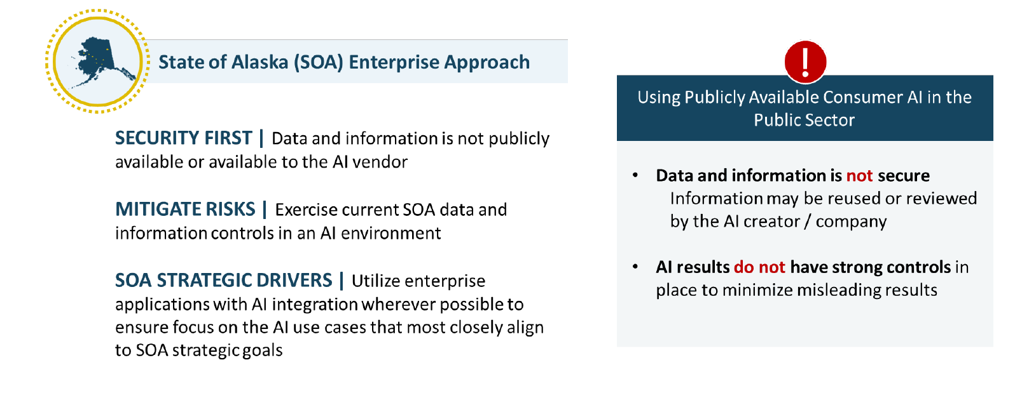
[Slide from Bill’s presentation]

Bill provided an overview of Enterprise Generative AI in the State of Alaska, which he divided into three categories: Custom Build AI, Developer AI, and End User AI.

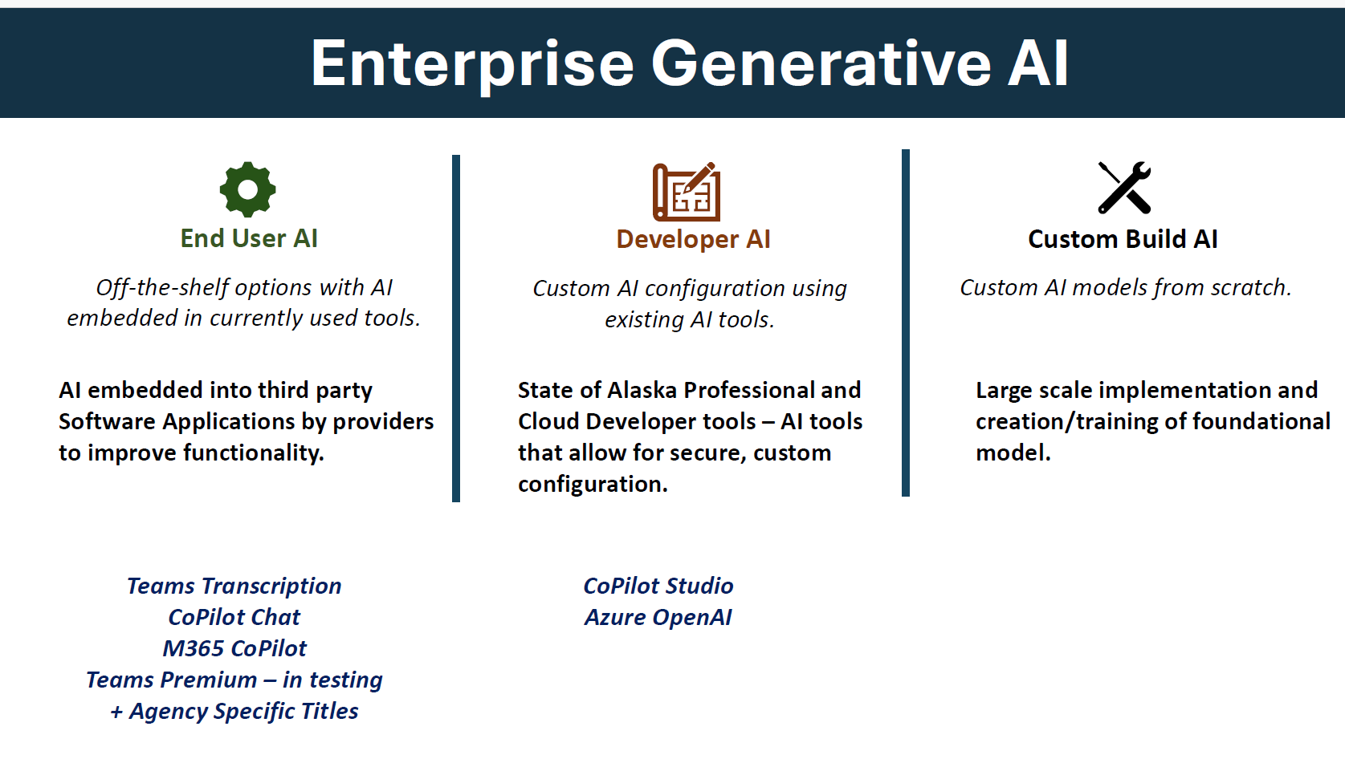
[Slide from Bill’s presentation]

Custom AI is very expensive and requires a significant amount of focus on how the model is trained to avoid inherent bias. The State of Alaska is not looking at custom AI at this time. It would be both costly and require a great deal of oversight.

A few departments are working on developer AI projects. This is where an agency can use existing AI tools and add code to customize and adapt tools for specific agency work. One such project involves the use of Copilot which allows the use of AI tools in the Azure environment for use in everyday tasks. Bill’s team put a State of Alaska chatbot template together and some departments, such as the Department of Health are using it. The Department of Natural Resources has built a tool to digitize field notes, including notes scribbled in the margins. The tool puts the data into a structured and searchable format.

Currently the most impactful category of AI being used by the State of Alaska is End User AI. This comprises of off-the-shelf options which are included in software applications such as CoPilot Chat, TEAMS Transcription, M365 CoPilot, and TEAMS Premium. TEAMS transcription which is part of Microsoft 365 is available to all Departments. TEAMS transcription can generate meeting notes which can then be summarized in CoPilot. CoPilot is available in all executive branch agencies now. CoPilot is set up for conditional access and use. When the user is signed into the user’s account, access is provided to the internet for input, but the user’s information is not shared externally. This is basically a secure version of Chat GPT.

About 800 state employees are using the higher version of M365 CoPilot. This can be used in Outlook for summarizing emails, action items, refining drafts in Word, developing presentations, and identifying persons from transcriptions who are responsible for specific action items. OIT just

finished a two-month pilot and will be publishing the results soon. This is a useful tool for certain positions but has a monthly cost per employee so OIT is undertaking a cost/benefit analysis. OIT is also testing TEAMS Premium.

While controls and security are applied to the state’s use of Microsoft 365, and information will not leave the TEAMS meeting environment to train and be available to Microsoft, care must be taken to ensure that only intended invitees are present. If a person is included for a specific meeting and not removed for subsequent meetings, that person will continue to have access to meeting content. Further, if a person attends your meeting and adds an AI notetaker of their own, meeting information will be made available to that tool. This may not be a concern as long as sensitive information is not discussed at the meeting. Each agency needs to decide whether and under what circumstances it will allow external transcription AI tools. If used, information from the meeting will be stored somewhere that is proprietary to that AI tool.

Bill provided an overview of the MyAlaska mobile app available through the Google and Apple stores since July 2025. The Administration wanted a single point of entry for all digital services for Alaskans. This app was done quite quickly and inexpensively. The goal is to replicate the MyAlaska portal and to improve navigation. It has a look and feel similar to the webpage, has a chatbot, and includes all the services available on the web. The app needs improving but has been designed so that it can be easily updated. Areas identified for improvement include adding more services, minimizing duplicate authentication, improving the user interface, and adding enhanced features.

Microsoft is coming to Alaska to present on the functionality of its AI tools. Department OIT officers will be invited.

October 23, 2025
- Helen Sharratt | Integrated Justice Coordinator | - Alaska Court System
Lars Johnson | Deputy PD | - Alaska Dept. of Admin, Public Defender
Vacant |  | - Alaska Justice Information Center
Angie Rosales | Victim Witness Coordinator | - Anchorage Municipal Prosecutor’s Office
Tracy Frable | APD Records | - Anchorage Police Department
Brian Brossmer | Research Analyst | - Alaska Judicial Council
Michal Bowers | PBK Coordinator | - Alaska Dept. of Law
VACANT |  | - Alaska DOT, Program Development
Sean Case | AACOP President | - Alaska Association of Chiefs of Police (AACOP)
- James Dabbs-Ashworth  David Muise | Acting DP Manager | - Alaska Dept. of Corrections
Lauren Whiteside | Driver’s Services | - Alaska DOA/Division of Motor Vehicles
Tony Piper | ASAP Program Manager | - AK DHSS/Alcohol Safety Action Program (ASAP)
- Bridget Grieme | Info System Coord | - Alaska DFCS/Division of Juvenile Justice
- Robert Nave | Protective Svcs Spec | - AK DOH, Division of Health Care Services, Background Check Program
Scott Stair | Investigator | - Alaska Dept., of Revenue, CIU
VACANT | Traffic Records FARS | - Alaska DOT, AK Highway Safety
Lisa Purinton  - Kara Southerland | SWS Director  Deputy Bureau Chief | - Alaska Dept. of Public Safety, AST
Phillip Malander |  | - Alaska Division of Elections
Katherine Stodgell | Public Health Div. Manager | - Municipality of Anchorage (DHHS)
Kaela Watson | Policy and Planning | - AK DOH, Division of Behavioral Health
Chad Holt | Supervising Atty | 21. Alaska Native Justice Center
Kevin Richard/  Joe Bankowski | Director/ Special Investigator | 22. AMCO
Junnie Chup | CBJ Law | 23. City & Borough of Juneau – Dept. of Law
Krag Campbell  - Mareta Weed | Deputy Chief | 24. Juneau Police Department
Melanie Briggs  Miriam Freas  Demara Crim | Data Processing Mgt & ORCA Analysts | 25. Alaska DFCS/Office of Children’s Services
Beth Goldstein | Deputy Director | 26. Alaska DOA/Office of Public Advocacy
Michael Chiesa | Chief Investigator | 27. AK, DEC, Environmental Crimes Unit
David Kanaris | Chief, AK Crime Lab | 28. AK Scientific Crime Detection Laboratory
OTHER ATTENDEES
Ashwini Jarral, IJIS | Justin Bode, DPS | Jaime Ackerschott, DPS
Rachel Crowe, CMS | Ina Mano, ACS | Kathleen Wallace, DMV Director
David Bautis, ACS | Megan Salt, DPS | Evelyn Sharratt-Ash, AJC
Phillip Drennan, ACS | Anne Fajardo, ACS | Melissa Toppin, CMS
LOCATION | TEAMS

11:00 a.m. to Noon

Ashwini Jarral, Senior Advisor at the Integrated Justice Information Systems (IJIS) Institute discussed AI in field of Criminal Justice. His presentation focused on understanding basic concepts of AI and implementation considerations within the policing community. Ashwini provided extensive resources available through IJIS. These are detailed below and include a Use Case Catalog and AI Playbook for criminal justice implementation.

The IJIS Institute is a non-profit collaborative network working to improve operational outcomes, and implement technology to improve safety and efficiency in various fields, including criminal justice, through information-sharing. IJIS advocates for policies, procedures and standards for data sharing that improve safety and security. For more information about IJIS, please go to https://ijis.org/

Ashwini began by providing an overview of AI, defined as “machines mimicking human intelligence tasks”. Ashwini summarized AI in the image below (taken from his presentation). With Ashwini’s kind permission, the entire presentation was forwarded after the meeting to MAJIC members.

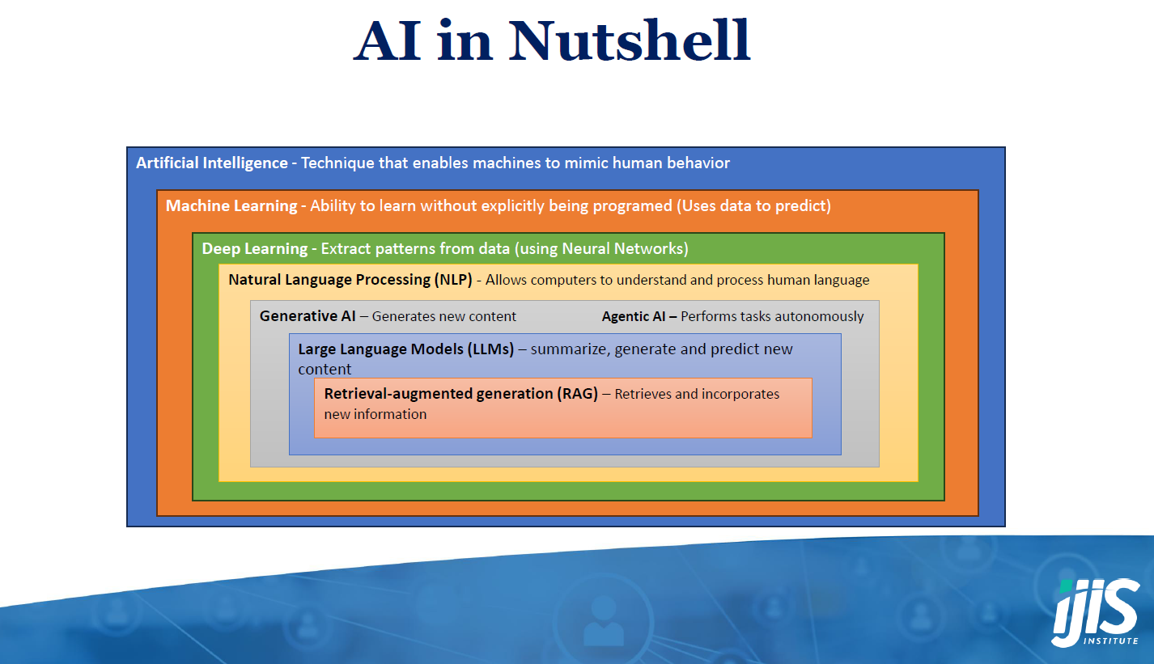

AI is intended to mimic human behavior. The core concept is machine learning, and within machine learning are additional layers explained in the image above. These layers encompass what we know so far as AI. Retrieval Augmented Generation (RAG) retrieves and incorporates all new information and is now being used by law enforcement to perform such work as writing

incident reports. As AI becomes capable of tackling more complex tasks, the human must always remain in the loop, and new legislation and policies must ensure accuracy and prevent bias.

Criminal justice systems are rule-based. AI can be built on predefined rules specified by human experts in the field of criminal justice. Coding must be done by domain experts and these models cannot be public. There should be a specific workflow for each use case, such as 911 calls. Rule based systems help ensure more transparency and explainability which are critical in public safety. There must be consistency and fairness in decision-making, and systems must be amenable to modification and maintenance. Specific criminal justice models can stay small and applicable to specific rules and use cases. Auditing for bias and accuracy is also critical.

The “elephant in the room” is data bias, and since all AI models carry some degree of bias, we have an ethical obligation to mitigate or remove bias during the training of AI models used in the criminal justice space. This requires understanding the causes of bias, avoiding use cases that would result in biased output, and reporting and auditing mechanisms to monitor the model. Monitoring can and should be done through regular analysis of logged prompts and results, and examining the environment generating data for drift or changes. Models must be built with auditing for bias built in, as well as the means to decommission or take them off line if bias and inaccuracy cannot be corrected. All states are looking at adding retention and logging requirements for all work generated using AI so that it can be analyzed routinely.

IJIS recommends the disclosure of the use of AI by agencies to promote transparency and trust. Inquiry is also important. For example, judicial officers should ask officers if they are using AI for incident reporting and request disclosure of what AI produced versus what the officer produced.

Agencies should consider policy development at a granular level, as well as having a generalized organization level policy. For example, there should be a separate AI policy for facial recognition, for license plate readers, drones, etc.

All agency stakeholders should be part of governance, and be engaged in identifying and updating requirements. Agencies must ensure that all feedback that improves the model is incorporated. A risk matrix should be developed and be use case specific. Staff must be trained, and understand policy regarding security, privacy, and comply with prohibitions.

IJIS has developed (and will continue to update) an Artificial Intelligence Playbook for Justice, Public Safety, and Security Professionals. This Playbook is intended to provide guidance for the development, and implementation of AI under agency policy. It is designed to be useful and covers critical considerations whether agencies are just starting out or have already adopted AI. The Playbook can be found here: https://ijis.org/community-resources/artificial-intelligence-playbook-for-justice-public-safety-and-security-professionals/

This playbook has already been used by the National Center for State Courts. Ashwini provided an overview of the 13 critical “Plays” (components) to focus on identifying agency roles for each “Play”:

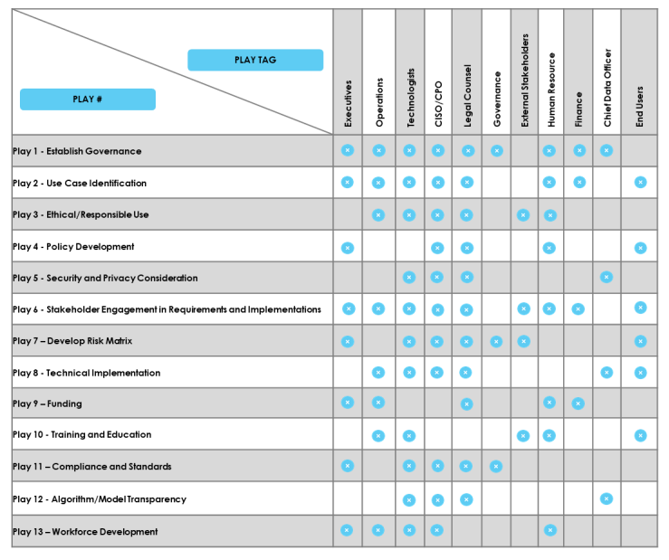

Last month, the IJIS Institute also published a use case catalogue for artificial intelligence in Justice and Public Safety. The areas covered by the catalogue include the following:

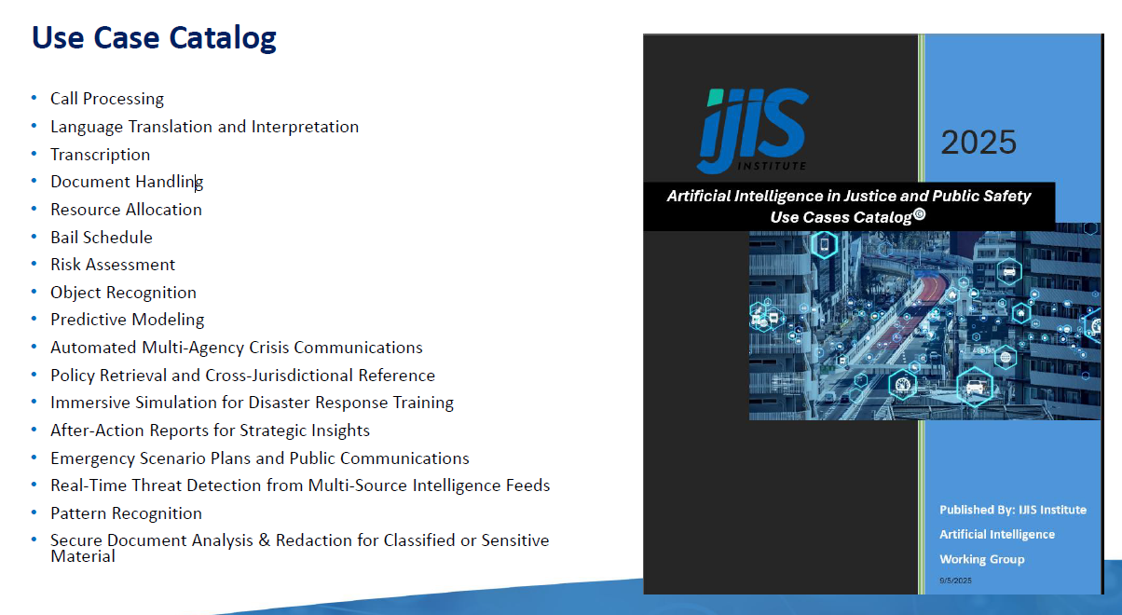

Some of these use cases have been implemented, and some are under development. The next version of the Catalogue will contain success stories in a large number of different use cases.

And, in partnership with the Miller Center on Policing and Community Resilience at Rutgers University and the University of Ottawa Professional Development Institute, IJIS has launched a Center of Excellence (COE) on Artificial Intelligence (AI) for Justice, Public Safety, and Security (JPSS). The stated mission of the COE is to provide one stop shopping for expertise on the responsible and ethical use of AI in justice, public safety and security. See https://ijis.org/ijis-key-initiatives/center-of-excellence-on-artificial-intelligence-for-justice-public-safety-and-security-jpss/ and https://aicoejpss.org/

The IJIS Institute provides technical assistance and is also available to review agency AI policies upon request. IJIS is standing up a lab to explore concepts and can work with agencies on developing possible models. Agencies can work with the COE to have models assessed for operational viability and validation. The COE Board is comprised of Law Enforcement, Corrections, Courts, Prosecutors, Public Safety, Homeland and private security. Participants are needed who can look at AI from an operational perspective. Princeton is working on an auditing tool for the IJIS Institute.

Ashwini encouraged agencies to avail themselves of the resources available through the IJIS Institute and to get involved in the work groups.

November 20, 2025
- Helen Sharratt | Integrated Justice Coordinator | - Alaska Court System
Lars Johnson | Deputy PD | - Alaska Dept. of Admin, Public Defender
Vacant |  | - Alaska Justice Information Center
Angie Rosales | Victim Witness Coordinator | - Anchorage Municipal Prosecutor’s Office
Tracy Frable | APD Records | - Anchorage Police Department
Brian Brossmer | Research Analyst | - Alaska Judicial Council
Michal Bowers | PBK Coordinator | - Alaska Dept. of Law
VACANT |  | - Alaska DOT, Program Development
Sean Case | AACOP President | - Alaska Association of Chiefs of Police (AACOP)
James Dabbs-Ashworth  David Muise | Acting DP Manager | - Alaska Dept. of Corrections
Lauren Whiteside | Driver’s Services | - Alaska DOA/Division of Motor Vehicles
- Tony Piper | ASAP Program Manager | - AK DHSS/Alcohol Safety Action Program (ASAP)
Bridget Grieme | Info System Coord | - Alaska DFCS/Division of Juvenile Justice
Robert Nave | Protective Svcs Spec | - AK DOH, Division of Health Care Services, Background Check Program
Scott Stair | Investigator | - Alaska Dept., of Revenue, CIU
VACANT | Traffic Records FARS | - Alaska DOT, AK Highway Safety
Lisa Purinton  - Kara Southerland | SWS Director  Deputy Bureau Chief | - Alaska Dept. of Public Safety, AST
Phillip Malander |  | - Alaska Division of Elections
Katherine Stodgell | Public Health Div. Manager | - Municipality of Anchorage (DHHS)
Kaela Watson | Policy and Planning | - AK DOH, Division of Behavioral Health
Chad Holt | Supervising Atty | 21. Alaska Native Justice Center
Kevin Richard/  Joe Bankowski | Director/ Special Investigator | 22. AMCO
Junnie Chup | CBJ Law | 23. City & Borough of Juneau – Dept. of Law
Krag Campbell  - Mareta Weed | Deputy Chief | 24. Juneau Police Department
Melanie Briggs  Miriam Freas  Demara Crim | Data Processing Mgt & ORCA Analysts | 25. Alaska DFCS/Office of Children’s Services
Beth Goldstein | Deputy Director | 26. Alaska DOA/Office of Public Advocacy
Michael Chiesa | Chief Investigator | 27. AK, DEC, Environmental Crimes Unit
David Kanaris | Chief, AK Crime Lab | 28. AK Scientific Crime Detection Laboratory
OTHER ATTENDEES
Jens Ludwig, U. of Chicago | Justin Bode, DPS | Jaime Ackerschott, DPS
Rachel Crowe, CMS | Carol Scoles, ACS | Kate Lampert, DMV
David Bautis, ACS | Megan Salt, DPS | Evelyn Sharratt-Ash, AJC
Phillip Drennan, ACS | Anne Fajardo, ACS | Melissa Toppin, CMS
James Stinson, OPA | Ina Mano, ACS | Andrew Dougherty, ACS
LOCATION | TEAMS

11:00 a.m. to Noon

Jens Ludwig, Edwin A. and Betty L. Bergman Distinguished Service Professor at the University of Chicago and author of “Unforgiving Places” presented an overview of a behavioral approach to addressing the problem of gun violence. He also discussed his work with the University of Chicago Crime Lab and the Chicago PD, and provided information regarding an open-source behavioral curricula for use in schools, detention and correctional facilities.

Jens believes that we have not made progress in reducing gun violence in the United States because we have not framed the problem correctly. Conventional wisdom explaining violent crime has generally been divided between viewing morally bad people, unafraid of the justice system as the cause on the one hand, and on the other, taking the position that it is caused by economic desperation and poverty. These differing views have led to governmental policies that have either promoted harsher penalties, or the need to provide access to greater opportunity (the so-called stick or carrot approaches). Jens believes that both approaches assume that humans stop to rationally compare the outcome of committing gun violence. However, in Chicago, Jens found that most shootings stem from interpersonal altercations, and not from calculated action or desperate need.

Jens also looked at two adjoining Chicago neighborhoods to examine if gun availability explained higher rates of violent crime. He compared Greater Grand Crossing and South Shore. Gun violence in Greater Grand Crossing is twice as high as in South Shore. However, the gun laws are the same in both neighborhoods, making gun availability the same. This led Jens to conclude that willingness to commit gun violence itself, rather than the fact of possessing a firearm must play a role in causation.

Most of our thinking is not intentional, it is automatic, and reactive. Under stress, humans are prone to make automatic and often incorrect assumptions about the situations they face. Reacting based on these assumptions during interpersonal conflict when a gun is present can be fatal.

Through implementation of a trial Becoming a Man (BAM) youth guidance behavioral program, a significant reduction in violent offenses was noted. The behavioral training provided feedback on navigating the world, how situations are easily misunderstood, how tensions escalate, and how to stop and think before reacting violently when fighting is not necessary. This trial was then replicated and showed consistent decreases in recidivism. Jens concluded that situational violence can be addressed by teaching self-interruption, and that behavioral approaches to reducing violence are more effective than either the imposition of harsher penalties or the provision of incentives.

Jens shared links to the work of the Crime Lab, statistical outcomes, and the open-source behavioral curricula which can be adapted to be provided in youth and adult correctional facilities by staff. The Crime Lab also developed a BAM for police officers to be included in annual training. The Sit-D Program has resulted in fewer incidences of use of force, for example.

Resources are available on the Crime Lab website (links below). Jens also extended an open invitation to Alaska’s agencies to contact him directly with any questions.

https://crimelab.uchicago.edu/

https://crimelab.uchicago.edu/projects/situational-decision-making/

https://crimelab.uchicago.edu/methodologies/behavioral-science/

https://urbanlabs.uchicago.edu/news/cbt-2-0-a-behavioral-approach-to-reducing-recidivism-among-youth

